Squaxin Island Tribal

Comprehensive Emergency Management Plan

(CEMP)



APRIL 2008

Table of Contents

PREFACE 4

LETTER OF INSTRUCTION 5

INTRODUCTION
- Mission 7
- Purpose 7
- Scope 8
- Organization of the Plan 8

POLICIES
- Authorities 11
- Continuity of Government 12
- Goals 13
- Definitions 14

EMERGENCY LEVELS
- Level 3- Minor, Localized Incidents 15
- Level 2- Major Emergency with Disruptions 15
- Level 1- Tribal Disaster 16

EMERGENCY AND DISASTER MANAGEMENT
- Pre-Incident Planning and Preparedness 16
- Emergency and Disaster Operations (NIMS) 16
- Combined Operations ICP/EOC 19
- ICP/EOC Section Responsibilities 19
- Communications and Coordination 24
- Post-Incident Recovery 24
- Plan Deactivation 24
- Cost Recovery 24
- Plan Reassessment 25
EMERGENCY INFORMATION AND COMMUNICATIONS
- Notifications 26
- Declaring a State of Disaster 26
- Transmitting Emergency Information (WebEOC) 27
- Information Distribution 27
CLASSIFICATION OF RESPONDERS 28

Appendix A: Glossary of Terms 29

Appendix B: Tribal Resolutions Pertaining to Emergency Management 40

Appendix C: Supporting Plans/Procedures to the CEMP 46

Appendix D: Example of Potential Actions Taken for an Incident 47

Appendix E: Tribal Departmental Assignment Chart (ICP/EOC Sections) 49

Appendix F: Emergency Support Functions 50

Appendix G: Operational Planning Guidelines 52

Appendix H: Implementation Plan 53

Appendix I: Training Plan 54

Appendix J: Testing and Evaluation Process 55

Appendix K: Continuous Improvement Process 56

Appendix L: Tribal Implementation of WA. State Sponsored WebEOC 57

Appendix M: Plan Maintenance Time-Table 58

Appendix N: Continuity of Government (Emergency/Disaster) 59

Appendix O: Incident Types (U.S. Fire Administration) 60
Appendix P: Mutual Aid Agreements (Template) 62
Appendix Q: EOP Planning Guide 67

Appendix R: Tribal Transition from Response-To-Recovery 71

Appendix S: Emergency/Disaster Contracts 72

Appendix T: Emergency Operations Center (EOC) Location/Alternate EOC 73

PREFACE

The Squaxin Island Tribe’s Comprehensive Emergency Management Plan (CEMP) is not just a requirement of the National Incident Management System (NIMS) and the State of Washington, but a representation of our commitment to protecting our community, which consists of the tribal reservation and our a-joining neighbors. It is a true example of the definition of Comprehensive; meaning it addresses, either within the base plan itself or through sub-planning, all four phases of Emergency Management; Mitigation, Preparedness, Response, and Recovery.

We acknowledge the fact that government’s responsibility to protect Every Person and All Assets only increases during an emergency/disaster. It is government’s responsibility to recover effectively and efficiently. This document prepares our government to meet our obligation to the best of our ability.

As a sovereign nation, we have exercised our right to protect ourselves by applying the four phases of Emergency Management, but not in a traditional sense. Our focus is RECOVERY, which we achieve by applying Mitigation, Preparedness, and Response. We recognize the fact that if we do not RECOVER, we have failed.

It is the responsibility of any government to provide services to its members on a consistent basis, which includes during an emergency and/or disaster. We as a tribe do not take this responsibility lightly or in passing. We are committed to ensuring our government continues to provide the essential Emergency Support Functions (ESF) regardless of the incident.

As an overview, the tribe is divided into two distinct sections: Tribal Government, which provides governmental services to our members which include representation. Enterprises; which consists of multiple business activities that provide a vast array of products and services. On a daily basis, each functions with little oversight from the other. However, in an emergency and/or disaster, all tribal assets fold under Government where each are assigned to a specific operational section responsible to ensure critical functions are performed, giving us the ability to suspend normal operations of both sections; resulting in the joining of Government and Enterprises into a single asset ready to overcome any adversity.

By Tribal Resolution, the Squaxin Island Tribe has declared our intent to institute the guidelines established in the Revised Code of Washington 38.52, which grants local organizations and joint local organizations authority to establish, operate, and exercise emergency powers, and procedures under Washington State Law; while maintaining the authority of the Tribe under its Constitution, Bylaws, and inherent sovereignty.

Through additional Tribal Resolutions (Appendix B), we have adopted the National Incident Management System (NIMS), which utilizes the Incident Command System (ICS) throughout tribal operations; by appointing Tribal Area/ Incident Commanders and transferring tribal government, in an emergency and/or disaster, to the Tribal Emergency Operations Center (EOC), which supports Continuity of Government (COG), by establishing emergency lines of authority through simplifying government. To better understand how we apply our system, refer to Appendix C.

Ray Peters
Executive Director
Squaxin Island Tribe

LETTER OF INSTRUCTION

General

The Comprehensive Emergency Management Plan (CEMP) is effective with the passing of Squaxin Island Tribe Resolution. All additional revisions will become effective once reviewed and approved by Tribal Council. This is the primary document for managing emergencies/disasters. For the Glossary of Terms see Appendix A of this plan.

Compliance

Instituting this document throughout tribal government, is the responsibility of the Emergency Manager and the Emergency Management/Homeland Security Committee (EMHSC). All Tribal Assets are expected to comply as directed. Tribal staff will be identified and placed within the three categories of Tribal Responders; they will be trained in their responsibilities and assisted in preparing their Individual and Family Response Plans, which will allow them to respond when needed. The following actions will be taken:

- Departments will assist their respective Primary Section Chiefs in establishing Emergency Operations Plans (EOPs) based on their Section’s Responsibilities under ICS, either assigned to the Area Command Post (ACP)/Incident Command Post (ICP), Emergency Operations Center (EOC), identifying staff needs, and the needs of the community.
- All EOPs will include Activation Procedures, Response Requirements by Category, Duty Assignments, and Section/Departmental Priorities.
- Each EOP will establish a Critical Facilities List, Resource List, and Staffing List. This will include both on-hand and shortages.
- Training will be conducted for each responder category, and Human Resources (HR) will be notified if any issues arise pertaining to duty descriptions/classifications.
- All Individual and Family Preparedness and Response Plans will be filed with HR and departmental directors will maintain a copy. These will be reviewed and updated as prescribed by HR.
- All completed EOPs will be exercised by a tabletop within the department, assisted by the Emergency Manager. An evaluation will be provided and a time line established for corrective action, which complies with Appendix J “Continuous Improvement Process”.
- All Departments will comply with Appendix D, which identifies the operational Section they are assigned and the Primary Section Chief. Primary Section Chiefs are responsible for developing Sectional EOPs using all assigned sectional assets. Additional plans may be identified, such as Evacuation and Community Health; which will become the responsibility of the Section Chief to ensure these plans are completed as assigned. Primary Section Chiefs will ensure those Departmental Directors under their section are trained to assume the position of Section Chief.
- Each Section Chief is responsible for developing a maintenance process, which will assure their EOPs, and supporting documentation is current and functional.
- Any additional criteria, when established, will be provided to Section Chiefs through the Office of Emergency Management and Safety.

All tribal assets identified, will comply as instructed within the time-line published by the EMHS Committee. The point of contact is the Tribal Office of Emergency Management and Safety.

- INTRODUCTION

A. Mission

It is the commitment of the Squaxin Island Tribal Government to minimize the impacts of emergencies and disasters on our people, property, environment, and economic enterprises. Our governmental priorities are simple; Life Safety, Property Protection, and Incident Mitigation through RECOVERY; the most effective, efficient, and value added way possible.

B. Purpose

This document manages our approach to any incident by establishing the architecture for a systematic, coordinated, and a comprehensive approach to any incident, for the purpose of:

1. Formulating fundamental assumptions and establishing tribal policies that facilitate communications resulting in effective command and control.

2. Authenticating a managed operational approach that provides a tribal mechanism to facilitate the immediate delivery of the necessary assistance required by all tribal government, which includes all assets and the community.

3. Establishing a tribal coordination mechanism and structure to ensure other local, state, and federal plans are supportable if and when providing assistance through mutual aid.

4. Meeting the emergency planning requirements of Title III of the Superfund Amendments and Re-Authorization Act of 1986 (SARA); Robert T. Stafford Disaster Relief and Emergency Assistance Act (Public Law 106-390); the Revised Code of Washington State (RCW) 38.52.070; and by Tribal Resolution.

5. Addressing the three known limitations and three unknown limitations necessary to insure we accomplish RECOVERY.

Known Limitations:

- Money
- People
- Time

The three Unknown Limitations:

- Time the incident will occur
- Type and magnitude of the incident
- Who will be able to respond

C. Scope

- This plan applies to all Squaxin Island Tribal Assets, which are tasked to provide assistance in an emergency or disaster; including planning, coordinating, training, and exercising. This document describes actions to be taken when providing immediate assistance to any part of the tribe and its interests during an emergency/disaster.

- Assistance includes those actions and activities that support tribal efforts to save lives; protect tribal health, safety, tribal assets, and the environment. This could include tribal assets providing assistance under mutual aid agreements.

- The configuration of this plan: 1) Meet’s the definition of a Comprehensive Emergency Management Plan (CEMP); which is divided in to four sections Mitigation, Preparedness, Emergency and Disaster Management (addressing Response and Recovery), and Communications; 2) Allows each section to either be used individually or in support of one another; 3) Identifies actions and activities to be taken during Emergencies and Disasters supporting Emergency Level 3,2,1 and the Emergency Support Function (ESF) concept, which are based on existing state and federal guidelines.

D. Organization of the Plan

This CEMP is an all hazards plan, designed to meet the requirements of Squaxin Island Tribal Resolution and the Revised Code of Washington (RCW 38.52). To include the four phases of Emergency Management; Mitigation, Preparedness, Response, and Recovery by emphasizing the seamless transition between Response and Recovery entitled Emergency and Disaster Management.

We have established that Communications plays a critical role in establishing and maintaining Command and Control from the start of an event/incident to its finish. Therefore our focus is on maintaining communications regardless of the incident.

Our vulnerabilities are based on Mason County’s Hazard Identification and Vulnerability Assessment (HIVA). Our assumption is we will be adversely affected, either directly or indirectly, by any potential disaster within our county and region.

- The CEMP is our base plan and will act as the foundation document by which the Squaxin Island Tribe will conduct operations during emergency/disaster incidents. The Tribal Council will review the base plan, which discusses the mission, purpose, scope, concept of operations, and policies in an emergency/disaster; and the responsibilities of the Area Command Operations (ACO)/Incident Command Staff and Emergency Operations Center (EOC) in coordinating the efforts of all responders, which includes all additional requirements such as planning, training, exercising, the CEMP Planning Cycle, and Plan Maintenance (based on a Calendar Year) annually. The schedule will be posted in conjunction with the Training & Exercise.

- The CEMP itself is the primary document used by tribal government to mitigate any emergency/disaster. It is supported by four major sections, which are published separately and establishes three Emergency Levels, which identify specific actions to be taken depending on the magnitude of the event. Each Section of this plan, will consist of a specific action plan or plans that discusses:

  - Mitigation Section Plan-The natural hazard mitigation planning process;

- Organize resources
- Assess risks
- Develop a mitigation plan
- Implement the plan and monitor progress

  - Preparedness Section Plan-The Tribe’s documented approach to establishing a state of adequate preparations in case of an event.

  - Emergency and Disaster Management Section Plan- A seamless approach to managing large disasters with limited resources while instituting NIMS/ICS, Critical Infrastructure Protection; ensuring the focus is shared between Response and the necessity to RECOVER. This includes the Terrorist Annex (Sensitive Document).

  - Communications Section Plan- This will ensure that horizontal and vertical connectivity is established throughout the entire CEMP, and under the worse possible conditions. (Communications will be forefront in all our efforts.)

  - Emergency Levels, which are support by the United States Fire Administration [USFA] Incident Types (Appendix N) :

LEVEL 3: A minor, localized department or building incident [USFA Incident Types 4 and 5]

LEVEL 2: A major emergency that disrupts sizable portions of the tribal community [USFA Incident Types 3 and 4]

LEVEL 1: A disaster involving most or all tribal assets and surrounding community [USFA Incident Types 1 and 2]

- The Emergency Support Functions (ESF’s, Appendix E) will identify which tribal assets, under the supervision of the assigned Section, are responsible for developing action plans required to support the Section Emergency Operations Plans (EOP). These action plans describe how each asset will accomplish their responsibilities, concept of operations, and their training and exercise requirements. Tribal Government has assigned specific actions under the JURISDICTION ESFs below.

Federal Response ESFs

ESF1 Transportation/Evacuation
ESF 2 Communications and Warning
ESF 3 Public Works/Engineering
ESF 4 Firefighting
ESF 5 Emergency Management
ESF 6 Mass Care, Shelter, and Food
ESF 7 Resource Support
ESF 8 Health and Medical Services
ESF 9 Search and Rescue
ESF 10 Oil and Hazardous Materials Response
ESF 11 Natural Resources
ESF 12 Energy/Utilities
ESF 13 Public Safety and Security
ESF 14 Long-Term Recovery and Mitigation
ESF 15 External Affairs

Squaxin Island Tribe ESFs

ESF 16 Elders & the Disabled
ESF 17 Evacuation and Movement
ESF 18 Government-To-Government

State Comprehensive Emergency Management Plan ESFs

ESF 20 State and Federal Support
ESF 21 Recovery Operations
ESF 22 Law Enforcement
ESF 23 Damage Assessment
ESF 24-29 Reserved for State expansion

Tribal ESFs

ESF 30 Communications, Command and Control
ESF 31 Administrative Procedures and Records
ESF 32 Emergency Operating Center Operations
ESF 33 Community Emergency Assistance

4. Due to the tribe’s size and limited resources, the ESFs will be assigned to Sections within the Emergency Operations Center and Incident Command Post. Appendix E identifies the Section responsible for each ESFs. All Sectional EOPs will address actions to be taken to ensure their continuation. These requirements will be coordinated with and submitted to the Tribal Emergency Manager. It is the responsibility of each Primary Section Chief to incorporate these action plans into the appropriate Section Plan.

- This plan is intended to provide linkage with local, state, and federal
disaster planning organizations. It is also supported by other internal tribal EOPs. There will be no other Emergency Response Plan authorized. All additional planning efforts, staff training, and exercising will support this base plan. All Sections are accountable for accomplishing specific action outlined in this plan, identified in the ESFs in Appendix E of this plan, and any additional assignments coordinated through the Tribal Emergency Manager and supported by the EMHSC.

- All changes to this base document must be reviewed by the EMHSC and their recommendations provided to Tribal Council. The APPENDICIES of this plan may be changed by the EMHSC without the approval of Tribal Council. All changes both recommended and implemented, should be presented on the Tribal Corrective Action Form, which is a result of Appendix J: “Continuous Improvement Process”.

II. POLICIES

A. Authorities

This plan was designed and developed in consideration of tribal resolutions, state and federal codes:

1. Squaxin Island Tribe Tribal Council Resolutions (Appendix B)

2. Revised Code of Washington (RCW) 38.52 and 39.34.

3. Title 118 Washington Administrative Code (Emergency Management)

4. Public Law 93-288, The Disaster Relief Act of 1974, as amended.

5. Public Law 920, Federal Civil Defense Act of 1950, as amended.

6. Public Law 96-342, Improved Civil Defense Act of 1980.

7. Title III, Superfund Amendments and Re-Authorization Act of 1986.

8. United States Code: Title 42, Chapter 68, Disaster Relief

9. Code of Federal Regulations Title 44, Part 205 and 205.16

CHANGES AND REVISIONS TO THIS PLAN: Under the direction and supervision of the Emergency Management Homeland Security Committee, changes and revisions may be made to the APPENDICIES of this Plan. However, any changes to the base document are only temporary until approved by Tribal Council.

B. Continuity of Government

The secession of tribal government is the sole responsibility of the Executive Group. Appendix M of this plan is a reference to this section of the CEMP. Any differences between the list below and what appear in Appendix M; what follows below will have precedent over Appendix M.

In the event this plan is activated, The Continuity of Government in Standard Operating Procedures does not apply.

Continuity of Government during an emergency/disaster can only be changed when a new CEMP is legally adopted, complying with the guidelines of this plan.

The positions list, in the order as it appears below have full authority to act on behalf of tribal government to protect people, tribal assets, environment, and economy, to include instituting Revised Code of Washington 38.52., by formally declaring an Emergency and/or Disaster.

However, for this authority to transfer from one position to the next, down the list, the next higher position must be unavailable. In the event, the magnitude of an incident requires immediate action; positions 4, 5, and 6 (TCO, AC/IC) are authorized to activate the Squaxin Island Tribe Emergency Management System, to include formal Declaration of a State of Emergency and/or Disaster, in compliance with RCW 38.52. Once executed, a verbal authorization to declare an Emergency and/or Disaster, by the Tribal Council or the Squaxin Island Tribe, must follow within 24 hours from the initial declaration. Written authorization must be completed as soon as possible.

Squaxin Island Tribe
Continuity of Government
in an Emergency and/or Disaster

Tribal Council

Executive Director

Deputy Executive Director

Emergency Manager

Tribal Coordinating Officer (TCO)

Area Commander

Incident Commander (If the appointed person is a tribal staff member)

Deputy Incident Commander/EOC Supervisor

Finance and Administration Section Chief

Planning and Coordination Section Chief

Logistics Section Chief

Information Section Chief

Communications Section Chief

C. Goals

The goal of the Squaxin Island Tribe is to coordinate with local municipalities, Washington State, and Federal agencies in an emergency or disaster to ensure:

- Life Safety

- Property Protection

- Mitigate the effects of a disaster

- Prepare for emergencies and disasters

- Respond to emergencies

- To Recover from all emergencies and disasters

Our efforts will include:

1. Developing, as a minimum, a 72-hour self-sufficiency plan for our community.

2. Improve responder capabilities, applicable to emergency/disaster situations and related conditions on tribal land and for tribal assets.

3. Develop and publish Emergency Operations Plans (EOP) to guide tribal entities towards a functional involvement in an emergency or disaster.

4. Create an atmosphere of inter-organizational cooperation.

5. Coordinate the use of all available tribal assets, other governmental and private resources; including personnel, equipment, and supplies.

6. Maintain and improve our Area Command Operations (ACO)/ Emergency Operations Center (EOC) and develop the capability of a mobile EOC to ensure continuity of government during a disaster or related conditions, and provide technical and administrative support to emergency responders.

- Partnering with local jurisdictions to coordinate Search and Rescue operations for persons in distress and/or property by providing assistance when able.

- Provide for the continuity of tribal government and effective tribal leadership before, during, and after any event.

D. Definitions [For specific definitions see Appendix A of this plan]

- Emergency Levels
At the Squaxin Island Tribe, emergency incidents are classified as levels 3, 2, or 1 in order of their severity and potential impact. Tribal Emergency Levels are supported by Incident Types developed by the United States Fire Administration (Appendix N).
Tribal Emergency Levels follow the numerical rates of the Incident Types. However tribal government has only three levels, while the federal government has 5 types. The Incident Types (Appendix N) are only a guideline. Refer to Appendix C for specific requirements for the Tribal Emergency Levels in addition to actions taken recommended for each of the 5 Incident Types published by the U.S. Fire Administration (USFA).
SOME IMPORTANT NOTES
- The Tribal Emergency Management System can be activated 24/7, and will expand (ICS) when necessary.
- ICS, AREA COMMAND, is our operational approach for Command and Control. When deemed appropriate, it may transition to another ICS operational approach.
- AREA Commanders are appointed tribal staff members confirmed by the Tribal Council. They are authorized to delegate the necessary authorities to Incident Commanders (IC) who may not be tribal staff members.
- This Emergency Plan pertains to ALL LEVELS of Emergencies (3, 2, and 1).
- Whenever possible, the designation of a major incident's emergency level will be made by the Area Commander/Incident Commander (AC/IC), if they are tribal staff members, in consultation with the Emergency Manager and in coordination with Tribal Government outlined in Appendix M (Example: the Tribal Chairman, Executive Director, and Emergency Management/Homeland Security Committee [EMHSC]).
- The designated level for an incident may change as emergency conditions intensify or diminish. However, all incidents will also be classified under the Incident Types established by the U.S. Fire Administration, where those specific actions will be taken into consideration during the initial response. (Appendix P)
LEVEL 3: A minor, localized department or building incident that is quickly resolved with existing tribal resources or limited outside help, such as Fire, Law, and Emergency Medical Services. A Level 3 emergency has little or no impact on personnel or normal operations outside the locally affected area.
Examples: Odor complaint, minor medical emergencies, local minor chemical spill, plumbing failure or water leak.
LEVEL 2: Incident requires activation of the Emergency Plan. Impacted personnel and/or departments will coordinate directly with the necessary tribal assets to resolve the incident. All tribal polices will be followed as required.

Examples: building fire, significant chemical spill, serious medical situation, significant criminal activity, utility outage, severe flooding, OR an existing/imminent external emergency that may affect tribal personnel or operations.

LEVEL 1: A major emergency that disrupts sizable portions of the tribal community. Level 1 emergencies may require assistance from external organizations. These events may intensify quickly and have serious consequences for mission-critical functions, or may threaten life safety. A disaster involving most or all tribal assets and surrounding community. Normal tribal operations are suspended. The effects of the emergency are wide-ranging and complex; requiring a timely Disaster Declaration; require Tribe-wide cooperation and extensive coordination internally and could require external resource support.

Examples: Major earthquake, fire, storm, power-outage, and environmental incidents.

- EMERGENCY AND DISASTER MANAGEMENT
- Event and Pre-Incident Planning and Preparedness: When at all possible, prior incident planning and preparedness will be conducted. It is the responsibility of the Tribal Emergency Manager (TEM) and EMHSC to ensure communication networks are established with those organizations which provide pre-incident warnings to government. A list of those organizations will be created and maintained by the TEM and accessible by those staff members who are designated Key Staff. This section will also be instituted to support any event determined to be significant and/or has the potential of becoming an incident.

When prior notification of an event and/or potential incident occurs; the following action will be taken:

  - An Area Commander (AC) will be appointed.
  - The AC will develop an Event/Incident checklist.
  - The AC will identify Incident Commanders (IC), EOC Supervisor, and Section Chiefs, if necessary; and schedule a planning meeting as soon as possible. During this meeting an IAP will be developed. (NOTE: DURING THIS INTIAL MEETING, THE GROUP WILL DISCUSS ACTIVATING THOSE SECTIONS [WITHIN THE EOC] NECESSARY TO SUPPORT THIS OPERATION.)
  - At the conclusion of the IAP meeting, under the direction of the EOC Supervisor, the Primary Sections Chiefs will coordinate the activation of their sections and, on behalf of the AC, release non-essential assets within their sections. Once these actions are completed the EOC Supervisor will notify the AC.
  - Once the IAP is completed and reviewed by the EMHSC, time permitting, the AC will provide the ICs the necessary written authority to accomplish their assignments as outlined in the IAP. In those cases where an event becomes an incident, the AC has the authority to issue verbal authorization to ICs, which could alter their previous authority, but will be followed by written authorization.
  - The AC will contact State EMD to request an Incident Number and will complete the WebEOC Checklist.
  - Once activated the EOC will become the Area Command Operations/ Staging Area/Base Camp, until changed by ICS.
  - As soon as possible a coordination meeting will be scheduled with the identified assets providing support, conducted at the EOC. Within this communication, the drafted IAP will be provided.
  - The Tribal Communications Plan will be activated.

- Emergency and Disaster Operations: The Squaxin Island Tribe complies with the National Incident Management System (NIMS). The Incident Command System (ICS) is the tribal standard for managing all emergencies and disasters. Within the ICS structure, the tribe will institute AREA COMMAND. ICS is an emergency management model used by the federal, state, county, and municipal governments, which assigns personnel at an EOC in functional working groups to maximize efficiency.
In order to provide appropriate and complete support, EMHSC principals will designate a responsible individual with sufficient knowledge and authority to act in their absence. Normally, the Group will assemble at the ICP/EOC designated by the positions in the following order: the Area Commander, Incident Commander, Deputy Incident Commander/EOC Supervisor, or the Finance and Administration Section Chief (Appendix M). This will allow for close coordination of management decisions and maximize use of available resources.
Executive Group
- Tribal Council
- Executive Director
- Deputy Executive Director
Tribal Incident Management Team
- Executive Group
- Area Commander (Designated ICs)
- Emergency Management Homeland Security Committee (EMHSC)
- Senior Officer Mason County Fire Dist 4 (MCFD 4)
- Tribal Emergency Manager
- Appointed Senior Member of the Tribal Recovery Team
Emergency Management/Homeland Security Committee (EMHSC)
- Is a cross-disciplinary group of individuals representing ICP/EOC Section Chiefs, which assist in developing emergency response plans and procedures for the tribal community; meets on a periodic basis to review the Tribal Emergency Plan and Homeland Security issues; and acts as a resource for the development of Departmental Emergency Plans. Includes appointed Incident Commanders, ICP Section Chiefs, EOC Supervisors, and EOC Section Chiefs.
- Provides executive oversight for the emergency response process.
- Acts as primary interface for Tribal Governmental and asset support, external communications and resource support.
- Coordinates Short and Long-term Recovery.
- Includes reviewing and providing recommendations for the CEMP, Departmental Emergency Operations Plans (EOP), and provides executive administrative guidance in the form of Administrative Policy Statements, support in the form of funding and personnel, and emphasis in the form of direction to administrative and support units.
Disaster Communications Center:
- Every department, building and floor on tribal property (essentially any location where an emergency of any type could occur) must have contingency plans for the proper response to emergencies, prepare to coordinate an emergency response in their location, and anticipate communications between the Emergency Operations Center and their location. The Tribal Emergency Plan, Department Emergency Plan Guidelines, and common sense shall serve to guide the development of Disaster Communication Center Emergency Plans. For consistency, these shall be referred to as Department Emergency Plans, even when they refer to emergency plans for other units.
Emergency Manager
- Designated point of contact for executive/senior administration communications and decisions affecting control of, and response to emergencies.
- Senior member of the Emergency Management/Homeland Security Committee and Supervisor of the Emergency Operations Center .
Area Commander (AC):
- Overall supervision of the incident(s) on tribal land and assets.
- Full authority, when appointed, to act on-behalf of Tribal Government.
- Grants authority to Incident Commanders on behalf of Tribal Government.
- Responsible for managing all response and recovery efforts.
- The authority to Evacuate and Quarantine in part or whole tribal assets.
- Ability to suspend tribal operations and evacuate tribal assets.
- Declare a Tribal State of Emergency and/or Disaster.
- Allocate tribal assets as necessary.
Incident Commander (IC):
- On scene emergency response coordination.
- Fully responsible for field activities required to control the scene and respond to the emergency.
- Directs emergency response personnel as required to reduce the extent and impact of the emergency.
- Single point of contact between the Emergency Operations Center and all field operations units.
Public Information Officer:
- Responsible for Tribal Relations during any Tribal emergency.
- The only spokesperson for Tribal external communications unless otherwise designated by the AC/IC and/or the EMHSC.
- A designated single point of contact between the Tribe and the media.
- Funnels information from the scene (Incident Commander), the Emergency Operations Center (when activated) and administration to both the Tribe and the local community.
- Responsible for establishing and supervising the Joint Information Center (JIC).
Incident Command Post (ICP) is responsible for direct action to control the emergency situation. This group is overseen by the AC and is under the direct supervision of the Deputy Incident Commander(DIC)
- Finance and Administration
- Logistics
- Planning
- Liaison Officer
- Public Information Officer
- Safety Officer

Emergency Operations Center (EOC)
- Provides specialized services and resources to assist the AC/IC, EMHSC, and Recovery Group (See Appendix A). Normally, a representative of the units below will report to the EOC in a Level 1 emergency. During a Level 2 emergency, a representative from these units will be tasked to report to the Emergency Operations Center as the situation warrants. In some cases, a representative may be contacted to support a Level 3 emergency.
- COMBINED OPERATIONS: Incident Command Post (ICP) / Emergency Operations Center (EOC): Due to the tribe’s limited resources and personnel, the ICP and EOC will function together. However, operations may be separated when determined to be more beneficial to tribal response efforts. The ICP/EOC expands or contracts for Level 3 or Level 2 emergency situations as required. Its structure will always follow the standard AREA COMMAND version of the Incident Command System (ICS). In all events, the TCO/AC, will be a Squaxin Island Tribal Representative. The Squaxin Island Tribe also partitions emergency decision-makers into functional Sections at the ICP/EOC, but these groups are modified to reflect tribal organization and their expertise in preserving Tribal culture, traditions, and assets.

- INCIDENT COMMAND POST AND EMERGENCY OPERATIONS CENTER
Section Roles and Responsibilities:

Incident Command Post (ICP)
[On-Scene Incident Command & Control/Communications/transitions during Recovery]

Plans Section: Is responsible for providing planning services for the incident. Under the direction of the Planning Section Chief, the Planning Section collects situation and resource status information, evaluates it, and processes the information for use in developing action plans. Dissemination of information can be in the form of the Incident Action Plan (IAP), formal briefing, or through maps and status board displays.
- Collect and manage all incident-related operational data.
- Provide input to the Incident Commander and disseminate information throughout the ICS by preparing the Incident Action Plan.
- Supervisor preparation of the Incident Action Plan.
- Conduct and facilitate planning meetings.
- Establish information requirements and reporting schedules for Planning Section units.
- Determine the need for specialized resources to support the incident.
- Establish specialized data collection systems as necessary (e.g. weather).
- Assemble information on alternative strategies and contingency plans.
- Provide periodic predictions on incident potential.
- Report any significant changes in incident status.
- Compile and display incident status information.
- Oversee preparation of the Demobilization Plan, or Recovery Transition Plan. (All Recovery Transition Plans will be coordinated with the Coordination Unit with the EOC)
- Incorporate Traffic, Medical, Communications Plans, and other supporting material into the Incident Action Plan.

RECOVERY OPERATIONS: Planning Section is responsible for creating a Recovery Transition Plan (RTP), which will be coordinated with the Coordination Section in the EOC, prior to deactivating and transitioning in to the Coordination Section in the Recovery Operations Center (ROC).

Logistics Section: provides all incident support needs with the exception of logistics support to air operations. The Logistics Section is responsible for providing resources in support of the IC from within the organization with the assistance of the Resource Management Section or acquiring them from outside sources;
- Facilities
- Transportation
- Communications
- Supplies
- Equipment maintenance and fueling
- Food services (for responders)
- Medical services (for responders)
- All off-incident resources (These responsibilities will be transferred to the Resource Management Unit in the EOC during Recovery Operations.

Major responsibilities of the Logistics Section Chief are to:
- Manage all incident logistics.
- Provide logistical input to the Incident Commander in preparing the Incident Action Plan.
- Brief Logistics Branch Directors and Unit Leaders as needed.
- Identify anticipated and known incident services and support requirements.
- Request/order additional resources, as needed.
- Develop as required, the Communications, Medical, and Traffic Plans.
- Oversea demobilization of the Logistics Section. (During Recovery, these functions will be performed by the Resources Management Unit in the EOC).

RECOVERY OPERATIONS: Logistics Section is responsible for creating a Recovery Transition Plan (RTP), which will be coordinated with the Resource Management Section in the EOC, prior to deactivating and transitioning to the Resource Management Section in the Recovery Operations Center (ROC).

Finance/Administration Section: Is responsible for managing all financial aspects of an incident. All incidents will require financial review.

Major responsibilities of the Finance/Administration Section Chief are to:
- Manage all financial aspects of an incident to include Recovery Operations.
- Provide financial and cost analysis information as requested.
- Ensure compensation and claims functions are being addressed relative to the incident.
- Gather pertinent information from briefings with responsible agencies.
- Develop an operating plan for the Finance/Administration Section; fill Section supply and support needs.
- Meet with assisting and cooperating agency representatives as needed.
- Maintain daily contact with agency(s) administrative headquarters on finance matters.
- Ensure that all personnel and equipment time records are accurately completed and transmitted to home agencies, according to policy.
- Provide financial input for demobilization planning.
- Ensure that all obligation documents initiated at the incident are properly prepared and completed.
- Brief agency administrative personnel on all incident-related financial issues needing attention or follow-up
- Preparing and implementing a Financial/Administration Section Recovery Transition Plan (RTP).
- If necessary conducting payroll activities for the ICP/EOC.

RECOVERY OPERATIONS: The above activities will remain in effect from Response and transitioning to Recovery. Finance/Administration will ensure all incident expenses can be provided to State/Federal Government for the purpose of fund recovery.

Emergency Operations Center (EOC)
[Governmental Command & Control/Communications during Response & Recovery]

Coordination Section: This unit is responsible for developing and implementing the Recovery Action Plan (RAP) beginning immediately during response, which includes developing objectives and identifying necessary resources to accomplish the objectives. It will also be the lead unit in coordinating resource needs identified in the RAP with the Resource Management Unit, and will assume responsibility for the ICP Deactivation Plan. Primary recovery responsibility for both short and long-term are: Utilities, transportation routes, long-term housing needs, re-building, and new construction. In addition, they will assist in managing and coordinating the Staging Area, Base and Camps in support of the DIC/EOC Supervisor.

RECOVERY OPERATIONS: Will assume the responsibilities of the ICP/Plans Section, as outlined in the Planning Section’s Recovery Transition Plan (RTP), during the Recovery Phase of the Operations. Is responsible for providing planning services for Recovery. Under the direction of the Coordination Section Chief, the Coordination Section collects situation and resource status information, evaluates it, and processes the information for use in developing recovery action plans. Dissemination of information can be in the form of the Recovery Action Plan (RAP), formal briefing, or through map and status board displays.
- Collect and manage all recovery-related operational data.
- Provide input to the Recovery Commander and disseminate information throughout the Incident Recovery System (IRS) by preparing the RAP.
- Supervisor preparation of the RAP.
- Conduct and facilitate planning meetings.
- Reassign personnel transitioning from ICS to the IRS organizational positions as needed and appropriate.
- Establish information requirements and reporting schedules for Coordination Section units.
- Determine the need for specialized resources to support Recovery.
- Establish specialized data collection systems as necessary (Rebuilding, New Construction).
- Assemble information on alternative strategies and contingency plans, which include Post Mitigation Projects.
- Report any significant changes in recovery status.
- Compile and display recovery status information.
- Oversee preparation of the Demobilization Plan to support the RTP.
- Incorporate Traffic, Medical, Communications Plans, and other supporting material deemed necessary in the IRP.

Communications Section: Is responsible for maintaining incident communications as outlined in the Common Communications Plan and interoperable communications processes and architectures. This unit will assist in the analysis and development of both afore mentioned plans. During recovery the Communications Section will continue to support in the same capacity.
- Provide communications support both during the Response and Recovery Phases.
- Assist the Plans Section in the development of the ICS Communications Plan.
- Assist in the communications transition from Response to Recovery.
- Provide assistance to the Coordination Section in developing the Communications Section of the RAP.

RECOVERY OPERATIONS: During Recovery Operations this section will transition to the ROC as prescribed in their Recovery Transition Plan (RTP).

Resource Management Section: Will assume the responsibilities of the ICP/Logistics Section during the Recovery Phase of the operations. It is also responsible for acquiring, dispatching, tracking, recovering tribal resources per the RAP. It also includes the ordering of necessary assets and processes for reimbursement of resources, as appropriate. The ordering of additional resources will be requested through the Logistics Section within the ICP, coordinating authorization through the Finance/Administration Section of the ICP. This unit will establish shelters and feeding facilities to support the ICP. Tribal resources are defined as personnel, teams, equipment, supplies, and facilities available or potentially available for assignment or allocation in support of incident management and emergency response activities. This unit will also be responsible for supporting the needs identified in the IRP. This unit will assist the AR/IC/ in inventorying and accounting for all assets.

Will provide all incident support needs to include logistics support to air operations for all community victims requiring assistance. The Resource Management Section is responsible for providing tribal assistance with;
- Facilities
- Transportation
- Communications
- Supplies
- Equipment maintenance and fueling
- Food services
- Medical services (Long Term)

RECOVERY OPERATIONS: During Recovery Operations this section will assume the responsibilities of the Logistics Section as outlined in the Logistics Section’s Recovery Transition Plan (RTP.

Information Management Section: This unit is responsible for managing organizational processes for gathering, sharing, and managing incident related information. This includes record keeping for shelters, medical treatment areas, Disaster Reservists, community member; when requested, tribal staff family members, and oversee any other supporting plan information management needs. Additional responsibility will be to assist the tracking of incident response personnel.
- Maintaining the tribal client tracking database used for accounting for clients residing in the shelters, medical treatment areas, Disaster Reservists, community members.
- Assist the IC in recording responders and their assignments.
- Tracking responders within the Staging Area, Base, and Camp.
- Assisting the PIO in information gathering.
- Assisting in the coordinating Joint Information Center (JIC) Operations.
- Gathering information and supporting the Plans Section Chief in preparing the IAP.

RECOVERY OPERATIONS: Will assume the responsibilities of the Public Information Officer and Liaison Officer during the Recovery Phase of Operations. However, during Recovery the PIO will be assigned under this section when released by Executive Services.
- Assuming the responsibilities of the Liaison Officer during recovery.
- Gathering information and supporting the Coordination Section Chief in preparing the IRP.
- Assist the PIO in gathering and providing information.
- Provide support to Sections and Departments in Emergency Hiring.
- Assist in the deactivation of Disaster Reservists back to their normal staff positions.

- Communications and Coordination: The Squaxin Island Tribe CEMP is coordinated as outlined in RCW 38.52, the Federal Emergency Management Agency, and other tribes, local, State and Federal agencies and organizations to ensure that procedures are consistent with current practice, and that we are able to maintain effective emergency communications and coordination during an incident. Washington State WebEOC (Appendix K) is our primary event management tool; refer to this plan’s Communications Section (Table of Contents) for specific applications.

- Post-Incident Recovery: As the situation is stabilizing, the Executive Group may phase down the Incident Command Post (ICP)/ Emergency Operations center (EOC) and transition from an EOC to a Recovery Operations Center (ROC). To ensure a simple transition, all other positions will be maintained as outlined in this plan, which follows ICS naming conventions. An INCIDENT remains an INCIDENT until RECOVERY is complete. All operations will continue to function as outlined in this plan during all RECOVERY efforts.
Some services and resources may need to be implemented or continued during the recovery phase to ensure that the needs of the tribal community are met. Examples may include (but are not limited to) counseling services, transportation, facilities, documentation, and claims, housing and food service support.
- Plan Deactivation: When emergency conditions are stabilized, and normal tribal operations resume, the CEMP will be de-activated by the Emergency Management Group. A formal announcement will be disseminated using all emergency information and notification systems.
If the nature of the incident requires an extension of some emergency services, special work groups may be appointed by the Emergency Management/Homeland Security Committee to coordinate those continuing activities. These groups may need to consider:
- Tribal administrative space adjustments
- Support services for impacted students, faculty, or staff
- Community relief assistance

Cost Recovery: One of the final actions may be to appoint an Emergency Cost Recovery Work Group, which will support the TCO. The composition of the Work Group will be related to the nature and magnitude of the emergency, but will include a core membership representing:
- Tribal Coordinating Officer (TCO)
- Member of the Executive Group
- Comptroller
- Emergency Manager
- Director of Planning
- Designated units and/or departments
Tribal Enterprises are responsible for developing Business Contingency Plans as part of their preparation for potential business disruptions. These Business Contingency plans should become part of the Emergency and Disaster Management Section of the Tribal CEMP. Business recovery will be a regular feature of the Tribe’s Emergency Management Exercises. Departments will have advance copies of internal cost and loss documentation forms in their Department Emergency Plans to prepare them for the post-event claims process. Additional materials and guidance documents from external sources, such as the Federal Emergency Management Agency (FEMA), will be distributed as needed. All efforts will be coordinated with the Tribal Comptroller.

Plan Reassessment: Emergency Plans should be modified as a result of the emergency experience. The Emergency Management/Homeland Security Committee will prepare a written “After Action Report” and will coordinate Tribal CEMP and/or Emergency Plan changes. The Emergency Management/Homeland Security Committee will periodically review the Tribal CEMP and Emergency Plans, and recommend modifications as required to improve both planning and response to emergencies. The Committee will also meet on a regular basis to provide general oversight and review related policies, procedures, and Tribal activities to include; training, exercises, tribal asset emergency planning, and publish their findings.

OPERATIONAL NOTE
- In the event an Incident Management Team (IMT) is requested by the Tribal Council; the Tribal Area Commander will assume the position of Tribal Coordinating Officer (TCO) and will coordinate in conjunction with the Federal Coordinating Officer (FCO) and the State Coordinating Officer (SCO). The Incident Commander (IC), if a tribal staff member, will assume the position of AC, which then will oversee the operational aspect of the response.
- Evacuations and/or closures of tribal assets, to include tribal enterprises, can be authorized by the Tribal Area Commander/Incident Commander, any position within the Continuity of Government (Appendix M), and the Tribal Emergency Management/Homeland Security Committee (EMHSC). These actions will be communicated in-person when possible, or announced from the Tribal Joint Operations Center (Area Command Operations [ACO]/Incident Command Post [ICP] and Emergency Operations Center [EOC]). If the IC is not a Squaxin Island Tribe staff member, one will be assigned.
- WHEN ACTIVATED, SPECIFIC ESF WILL BE FORMALLY ASSIGNED TO SPECIFIC SECTIONS WITHIN TRIBAL GOVERNMENT; AND THE ADMINISTRATION TRANSFERRED TO THE APPROPRIATE SECTION WITHIN THE ACO/ICP/EOC.
- The AC/IC, when notified, determines Plan activation, and has the authority to take what ever actions are necessary for Life Safety, Property Protection, and Incident Mitigation, to include convening the Tribal Incident Management Team (TIMT). The AC/IC will ensure the on-call Emergency Operations Center (EOC) Supervisor activates the EOC and assumes their roll coordinating essential services, which includes promulgation of emergency information, are contacted. The EMHSC consisting of the designated Tribal Council Members (Chairman/Vice Chairman, Executive Director, Emergency Manager, AC/IC, ACO/ICP Section Chiefs, EOC Section Chiefs, and Director of Public Safety, plus other selected Executive Team members and other support personnel as required for the emergency). The EMHSC constitutes the Executive Group, which can expand or contract as necessary. The EMHSC will convene at the ACO/ICP/EOC, normally with technical and support staff, which consists of those positions outlined in Appendix D. Under standard procedures critical coordination and exchange of information will be via cell phone or radio (Refer to the Communications Section-Emergency Level Communications). The EG may also request that Disaster Communications Center (DCC) be activated if the Communications protocols are significantly affected by the event or it would provide critical service support for the emergency or disaster.

Example: When the CEMP is activated; the AC/IC and all EMHSC members will report to the designated ICP/EOC as soon as possible. In most, if not all cases, the Incident Command Post (ICP) will be established in conjunction with the Tribal EOC [designated as the ICP/EOC] to support all incident resources and information. Both activities will be coordinated from one location. Refer to Appendix D of this plan for the flow chart of the ICP/EOC Operations.
- Emergency Information and Communications
- Notifications: In any emergency, notifications to affected community members, facilities, Tribal assets, and staff must begin at once --- as the emergency response itself begins.
- Declaring a State of Disaster: The Squaxin Island Tribe Tribal Council Resolution (Appendix B) identifies those tribal positions that are authorized to declare a State of Disaster:
Tribal Council- Can formally declare a State of Disaster and is the signatory authority for formal written declarations.
The following positions are authorized to declare a State of Disaster; once declared a formal signed declaration will follow within 24 hours:
Tribal Chairman and Vice Chairman
Executive Director
Emergency Manager
Director of Public Safety and Justice
Director of Health and Human Services
Director of Planning
Area/Incident Commander
- Transmitting Emergency Information to WA State and Federal Governments: State supported WebEOC is the primary communications tool our tribe will use to communicate with the State of Washington EMD/EOC and the Federal Government during an emergency and/or disaster.
- Information Distribution:
Tribal Information: At the Squaxin Island Tribe, the delivery of internal and external emergency information is planned and coordinated by the Information Section Chief and the EOC. This Section will work with the IC, PIO, EOC, and designated Information Coordinators from each group represented at the EOC to obtain and deliver reports and announcements.
During a limited (Level 3) emergency, Public Safety alerts appropriate directors and managers of the situation and provides updates as required throughout the course of the incident. (In some incidents, Emergency Manager, in consultation with the On Call Incident Commander may also distribute bulletins to affected departments or issue media releases.
Timely internal and external emergency announcements during a Level 1 or Level 2 emergency requires a much broader approach involving many participants. Tribal members and assets, faculty, staff, and visitors must know what happened, where it happened, and what to do next. In some cases, the surrounding community may also require information.
During levels 1 and 2, emergency bulletins should be issued at least every two hours. Internal Tribal Operational Status Bulletins and external press briefings may be issued every two hours, on an alternating schedule. At least two general information management meetings are held daily during the course of the emergency.
A variety of resources are used to distribute internal emergency information and instructions, including:
- Tribal Emergency Operations Center:
- Appendix Q
- The Tribal website: http://www.squaxinislandtribe.org
- Voicemail, Email and fax broadcasts
- Staffed phone banks
- Posted bulletins
This coordinated approach to disseminating critical emergency announcements will provide quick, reliable and consistent information to our community and will reduce general demand on vital emergency communications lines.
In the event that emergency conditions suspend power and telephone service, emergency information, along with all emergency communications, will be profoundly restricted. The Internet, Messengers, cellular phones, and radios (police, citizen’s band and/or Amateur Radio) may be used until systems can be restored.
Immediately following the cessation of Level 1 or Level 2 emergency operations, a debriefing of the Emergency Management Group members, departments, and the affected Tribal community will be conducted to evaluate the effectiveness of the emergency response and recovery efforts. Results of the survey will be used to identify improvements to tribal plans.
- Classification of Responders
The Squaxin Island Tribe will have three responder categories to be utilized to perform within the classification of their descriptions.
- First Responders-Are identified as Fire, Law, EMS, Medical, Area Commander/Incident Commanders, EOC Supervisors, Section Chiefs, and other designated support staff.
- Emergency Responders-Those staff identified as critical to departmental operations and those filling positions within the EOC.
- Disaster Reservists-Tribal staff members and trained community members necessary to assist government becoming operational, to assist the tribal community, and/or perform specific tasks under a supervisor.
First Responders and Emergency Responders are trained to self-dispatch. Disaster Reservists will respond when contacted by tribal government; unless, they determine they would be safer on the reservation. All Tribal Staff Members are authorized to self dispatch, which includes their immediate family members to the reservation, when their safety is in question.
When self-dispatching, the staff member will contact the EOC and inform them of their intent, to include the bringing of family members. The EOC will inform the staff member of the shelter location and will coordinate with the shelter staff.
NOTE: ALL CLASSIFICATION; FIRST RESPONDERS, EMERGENCY RESPONDERS, AND DISASTER RESERVISTS WILL BE MAINTAINED IN A DISASTER RESERVIST DATABASE AND ISSUED THE APPROPRIATE RESPONSE DOCUMENTS.

APPENDIX A

GLOSSARY
OF
TERMS

72 Hour Self-Sufficiency Plan-A plan-of-action, which prepares the planner to survive on their own for at least 3 days without any additional assistance.

AC/IC-Area Commander/Incident Commander: A designation that represents either the Area Commander (AC) or the Incident Commander (IC) that is applied equally.

Area Command-Is an Incident Command structure that is a part of tribal government, which functions between tribal authorities and the Incident Commander(s). It provides command authority and coordination for an incident. The purpose of a Tribal Area Command is to oversee the management of any incident(s) that require an IC to be appointed who is not a tribal staff member, and/or when responders from outside the tribe are requested. This ensures tribal interests are considered and maintained throughout the response.

Area Commander (AC)-A tribal incidents Area Commander is appointed when assets are requested from outside of tribal government, or when it is determined that assets will be needed from outside the tribe at a future date. The purpose of the AC is to act on behalf of the tribal administrator during the operations phase. The AC is the first line supervisor for all ICs and is the tribal government’s representative in incident operations, to include acting as the Tribal Coordinating Officer until one is appointed. This position will always be a tribal representative.

Area Command Operations (ACO)-The functional element that supports the Area Commander (AC), where specific activities are performed in compliance with ICS. In the case of Squaxin Island Tribe, we include a Finance Section.

Assets-Economic resource that is expected to provide benefits to the tribe as a whole. An asset has three vital characteristics; (1) future probable economic benefit: (2) control by the entity; (3) results from prior event or transaction. Assets are expressed in money or are convertible into money and include certain deferred charges that are not resources (e.g., deferred moving costs). They can be recognized and measured in conformity with Generally Accepted Accounting Principles (GAAP). Examples of ownership rights or service potentials are cash, automobiles, and land. An asset may be tangible or intangible. The former has physical substance such as a building. The latter lacks physical substance or results from a right granted by the government such as goodwill and future services.

Base-The location at which primary Logistics functions for an incident are coordinated and administered. There is only one Base per incident. (Incident name or other designator will be added to the term Base. The ICP will be collocated with the Base.

Base Camp-The location at which primary Logistics functions for an incident are coordinated and administered, within the geographical site within in the general incident area. This site is equipped and staffed to support all function of the Base and Camp. Unless designated otherwise, during tribal operations the Base-Camp will be in the vicinity of the Tribal EOC.

Tribal Council-Is the elected official level of tribal government. They are elected by tribal members for a set term and represent the interests of the tribal community.

Business Continuity Plan-an all encompassing term covering both disaster recovery planning and business resumption planning. The umbrella term also refers to other aspects of disaster recovery, such as emergency management and human resources. BCP identifies procedures for sustaining essential business operations while recovering from a significant disruption.

Executive Director-Is the senior most executive officer, non-elected position, within tribal government.

Camp-A geographical site, within the general incident area, separated from the Incident Base, equipped and staffed to provide sleeping, food, water, and sanitary services to incident personnel. Unless designated otherwise, during tribal operations the Base and Camp will be combined forming the Base-Camp.

Chairman-The chief elected tribal official, which presides over Tribal Council and government.

Communication Plan-A formalized plan that explains how Tribal Government will establish and maintain communications: (1) With outside governments and agencies; (2) with Tribal Assets during an incident, emergency, and/or disaster.

Comprehensive Emergency Management Plan (CEMP)-The primary tribal document, formally adopted by the Tribal Council, which defines Tribal Governments responsibility for all four phases of Emergency Management; action during an incident, emergency, and/or disaster; and is the base document for all other activities pertaining to Tribal Emergency Management and Homeland Security.

Continuity of Government (COG)-Is the principles of establishing defined procedures that allows tribal government to continue its essential operations in the case of an incident/emergency/disaster that effects multiple governmental functions.

Critical Facilities List-A structure that is designated by Tribal Government to be necessary for us to meet our obligations during an incident, emergency, and/or disaster. These facilities will be maintained on a database, provided in list form to those governments deemed necessary by Tribal Government, and is classified as SENSITIVE INFORMATION when published in list form. This includes the Critical Facilities Database itself.

Delegation of Authority-A statement provided to the IC by the AC, either verbally or in writing, preferably in writing, delegating authority or assigning responsibility. The Delegation of Authority can include objectives, priorities, expectations, constraints, and other considerations or guidelines as needed. This will be provided to the IC prior to them assuming command.

Departmental EOPs-These are departmental specific Emergency Operations Plans that support the ICP/EOC Sectional Emergency Operations Plans. These documents help establish specific activities that will need to be performed to ensure the department is prepared to assist in accomplishing tribal government’s overall objectives. This plan also identifies critical staff positions, coordinates initial communication procedures and response criteria, explains the transitioning from SOPs to EOPs, who (by activity and/or function) is responsible for ensuring the department is prepared, and identifies additional staff training and exercise requirements.

Deputy Area Commander (DAC)-A fully qualified individual who, in the absence of the superior, could be delegated the authority to manage, a functional operations or perform a specific task. In this case the Deputy will act as relief for the primary and therefore is granted the authority to act of their behalf.

Deputy Incident Commander (DIC)- A fully qualified individual who, in the absence of the superior, could be delegated the authority to manage, a functional operations or perform a specific task. In this case the Deputy will act as relief for the primary and therefore is granted the authority to act of their behalf.

Disaster-Are incidents that exceed the capabilities of tribal government, reaching the level outlined in RCW 38.52., allowing a formal Disaster Declaration to be completed and submitted to Washington State.

Disaster Reservist(s)-Assists in addressing one of the three unknowns when facing any incident (who is going to respond?). Tribal Disaster Reservist(s) are trained responder(s) who will assist tribal government in managing and RECOVERING from any incident in which they are determined to be needed. All tribal Disaster Reservists will meet the State Of Washington requirements to participate, and come from multiple locations both inside tribal assets (Enterprises and Casino/Resort) and the community.

Emergency-Absent a Presidentially declared emergency, any incident(s), human-caused or natural, that requires responsive action to protect life or property. Under the Robert T. Stafford Disaster Relief and Emergency Assistance Act, an emergency means any occasion or instance for which, in the determination of the President, Federal assistance is needed to supplement State and local efforts and capabilities to save lives and to protect property and public health and safety, or to lessen or avert the treat of a catastrophe in any part of the United States.

Emergency Level-Are categories of response, which indicate the severity an incident has on tribal government and our community; 3 is the least severe and 1 being the most severe.

Emergency Level 1-A disaster involving most or all tribal assets and surrounding community. This includes any requests for Tribal Assets through Mutual Aid Agreements. [USFA Incident Types 1 and 2

Emergency Level 2-A major emergency that disrupts sizable portions of the tribal community. [USFA Incident Types 2 and 3]

Emergency Level 3-A minor, localized department or building incident [USFA Incident Types 4 and 5]

Emergency Management-Or disaster management, is the discipline dealing with and avoiding risks. It is a discipline that involves preparing, supporting, and most importantly ensuring social Recovery when natural or Human-made disasters occur.

Emergency Management Homeland Security Committee (EMHSC)-An advisory group in Emergency Management and Homeland Security, both inside and outside the tribe, for the Tribal Executive Group, consisting of: Executive Director, Area Commanders, Incident Commanders, Thurston County Fire District 1 Representative, Primary Section Chiefs, and Emergency Manager.

Emergency Management Model-An Emergency Management structure used to assist in predicting the impact of potential incidents on effected communities.

Emergency Manager- The tribal staff position that has coordination responsibility for tribal emergency management.

Emergency Operations Center (EOC)-The physical location where all tribal operations are overseen. In the event of a disaster, it is also the location where all tribal governmental functions transfer.

Emergency Operations Plan (EOP)-The document that each Section within the EOC and ICP has and maintains, which governs their actions during both Response and Recovery.

Emergency Responder-One of three designed tribal responders consisting of key tribal staff assigned to assist in Sectional Support Positions within the EOC and/or ICP and assists in restoring critical infrastructure necessary for tribal government to support the community .

Emergency Support Function (ESF)-Exist to assist in defining tribal government’s roles and responsibilities for the coordination and delivery of necessary services following an emergency or disaster.

Event-A planned, non-emergency activity occurring on or within Tribal Assets. ICS can be used as the management system for a wide range of events.

Executive Group-Senior Tribal Executives consisting of Tribal Council, Executive Director and designated executives.

Executive Services-Senior Tribal Executives consisting of Tribal Council, Chairman, Executive Director and their support staff.

Family Preparedness and Response Plan-A tribal staff plan that address key personnel preparedness and the preparedness of their family members.

Federal Coordinating Officer (FCO)-Appointed by the Director of the Federal Emergency Management agency, on behalf of the President, to coordinate federal assistance to a state affected by a disaster or emergency. The source and level of the FCO will likely depend on the nature of the federal response.

Federal Emergency Management Administration (FEMA)-A division within the Department of Homeland Security, responsible for limited response to, recovering from and mitigating against disasters, which meet the category of “Presidential Disasters” defined within the Stafford Act.

First Responder-Are those tribal staff members designated as immediate responders: Law Enforcement, Area Commander, Incident Command, Section Chiefs, Fire, and EMS.

Four Phases of Emergency Management-The process of emergency management involving four phases: mitigation, preparedness, response, and recovery.

HAZMAT Unit-A specifically trained group of first responders who dispatch to hazardous materials incidents.

HAZMAT Unit Commander-A trained professional who supervises the HAZMAT Unit.

Deactivation Plan-A planned and coordinated transition document, which either transfers continued operational responsibility or provides a scheduled close-out of an incident operation. These Plans will be completed during Response and Recovery, by the ACO, ICP, and EOC, when appropriate.

ICP Section Chief-Is a trained professional who supervises a specific function with the Incident Command Post. (Logistics, Finance/Administration, Operations, Planning)

ICP/EOC-A physical location where joint operational functions are conducted for the Incident Command Post (ICP) and the Emergency Operations Center (EOC).

Incident-An occurrence or event, natural or human-caused, that requires an emergency response to protect life or property. Incidents can, for example, include major disasters, emergencies, terrorist attacks, terrorist threats, wild land and urban fires, floods, hazardous materials spills, nuclear accidents, aircraft accidents, earthquakes, hurricanes, public health and medical emergencies, and other occurrences requiring an emergency response.

Incident Action Plan (IAP)-An oral or written plan containing general objectives reflecting the overall strategy for managing an incident. It may include the identification of operational resources and assignments. It may also include attachments that provide direction and important information for management of the incident during one or more operational periods. A tribal incident may have two IAPs; the Initial Incident (Chehalis Tribal Form IAP) and in larger incidents, one created by the ICP.

Incident Command Post (ICP)-Is one of the five predestinated temporary facilities and signifies the physical location of the tactical-level, on-scene incident command and management organization. For tribal incidents it will be co-located with the EOC.

Incident Command Staff-Consists of those positions within ICS making up the Command and General Staff.

Incident Command System (ICS)-Is a management system used to organize emergency response. ICS offers a scalable response to an emergency (incident) of any magnitude, and provides a common framework within which people can work together.

Incident Commander (IC)-Is the person responsible for all aspects of an emergency response, including quickly developing incident objectives, managing all incident operations, application of resources as well as responsibility for all persons involved. The Incident Commander sets priorities and defines the organization of the incident response team. In tribal response the IC receives their authority, and overall direction from the Tribal Area Commander. In most cases this person will be a tribal staff member; however, this may not be the case depending on the type and magnitude of the incident.

Incident Management Team (IMT)-Is an outside resource that can be requested during major incidents, which will oversee the requesting jurisdiction’s ICS structure.

Incident Recovery System (IRS)-A tribal structure created to ensure an efficient and effective transition form ICS (Response Activities) to IRS (RECOVERY Efforts), while maintaining the necessary command, control, and communications demands equally important to RECOVERY as in Response.

Inherent Sovereignty-Under the American legal system, Indian tribes have sovereign powers independent from the federal and state governments. The extent and breadth of tribal sovereignty is not the same for each tribe. Implicit in this principle is that only the federal government has the authority to change tribal powers, not the state. Another principle of federal Indian law is that tribes keep all rights and powers that they have not expressly given up. Tribes determine their own destiny.

Incident Types-Incidents are classified in order to make decisions about resource requirement based on their levels of complexity. There are five levels established by the United States Fire Administration. Refer to Appendix N of this plan.

Joint Information Center (JIC)-A physical location within the ICS where all responding agencies and jurisdictions conduct media relations and ensures a single message is communicated.

Liaison Officer (LNO)-A member of the Command Staff responsible for coordinating with representatives from cooperating and assisting agencies. The Tribal LNO could be assigned to key out-side coordination center (e.g. Supporting EOCs at the Local and/or State Level).

Mitigation-Efforts that attempt to prevent hazards from developing into disasters altogether, or to reduce the effects of disasters when they occur. The mitigation phase differs from the other phases because it focuses on long-term measures for reducing or eliminating risk. We apply two mitigation strategies: Pre-Mitigation, which is applied before an incident; and Post-Mitigation, which is part of the tribal recovery process. Both efforts are to reduce or eliminate risk over time.

Mutual Aid agreement-Written agreements between jurisdictions that they will assist one another on request, by furnishing resources.

National Incident Management System (NIMS)-Is the first-ever standardized approach to incident management and response. Developed by the Department of Homeland Security and released in March 2004, it establishes a uniform set of processes and procedures that emergency responders at all levels of government will use to conduct response operations.

Normal Tribal Operations-Tribal operations that are administered by a Standard Operational Procedure (SOP), which occur on a day-by-day bases.

On-Call-Emergency Responders able to respond within 2 hours from activation.

Post Mitigation Projects-A critical function during Recovery, which taking advantage of our ‘window of opportunity’ to make things better by executing the projects on this List.

Preparedness-In the preparedness phase, plans-of-action are developed for when the disaster strikes. This planning effort begins with Tribal Government, which must function regardless of the type or magnitude of an incident.

Primary Section Chief- The ICS title for individuals responsible for functional Sections. In tribal operations, Section Chiefs are the titles used in the EOC; which are tribally appointed staff position responsible for coordinating all activities and functions necessary to ensure their Section is capable of activating during an incident. This includes supervising the activities, training requirements, and assigning deliverables to Supporting Section Chiefs.

Public Information Officer (PIO)-A member of the Command Staff responsible for interfacing with the public and media or with other agencies with incident-related information requirements.

Quick Reference-Is used to locate specific information, necessary in an incident, quickly, without having to read the entire CEMP.

Recovery-Our goal is Recovery, which is restoring affected areas to its previous state. Our recovery efforts are primarily concerned with actions that involve rebuilding destroyed property, re-employment, and the repair of other essential infrastructure. An important aspect of our recovery efforts is taking advantage of our ‘window of opportunity’ to make things better by executing those projects on our Post-Incident Mitigation List.

Recovery Action Plan (RAP)-Consist on the same format and information provided on the IAP; however the focus is towards RECOVERY.

Recovery Group-A designated group of tribal staff members whose function is to ensure all tribal assets RECOVER at the same time. Only specific staff positions will be assigned in advance of an incident. The remaining positions will be determined based on the type and magnitude of the incident.

Recovery Operations Center (ROC)-The physical location where all command and control functions for RECOVERY will be located. In most cases it will have transitioned from the ICP/EOC in response to the ROC in recovery.

Recovery Transition Plan-This is a transitional plan (from Response to Recovery) used when ICP Sections and/or EOC Sections are downsizing; however, specific activities are still being performed or are awaiting execution. This plan will identify who is responsible for doing what activities remaining. This document will be used in creating the initial Recovery Action Plan (RAP) and will be a supporting document to the RAP until those specific actions are completed.

Resources-Personnel and major items of equipment, supplies, and facilities, available or potentially available for assignment to incident operations and for which status is maintained. Resources are described by kind and type and maybe used in operational support or supervisory capacities anywhere within the tribal operational area.

Resource List-A consolidated list of resources within tribal government.

Response-The mobilization of the necessary emergency services and tribal first responders in the disaster area.

Revised Code of Washington (RCW)-Washington State Laws that are enacted by the State Legislature and signed by the Governor.

Section Chief-(1) A supervisory position, either with the ICP or EOC, responsible for ensuring specific functions are performed: (2) The ICS title for individuals responsible for functional Sections. In tribal operations Section Chiefs are the titles used in both the ICP and EOC.

Section/Departmental Priorities-Those tasks identified by either Sections (within the ICP/EOC) and/or departments that must be achieved before either the Section/Department is capable of participating in the overall tribal government objectives.

Simplifying Government-The organized transition from day-to-day government, to a more streamlined government necessary for meeting a more complex set objects with fewer assets at their disposal.

Sovereign Nation-See Inherent Sovereignty

Staffing List-The list of key position necessary during an incident, which have no tribal staff member identified to fill.

Staging Area-Location at which incident assigned resources are held pending tactical assignment. In tribal operations the Staging Area will be located at the EOC.

Standby-First Responders

State Coordinating Officer (SCO)-The individual appointed by the Governor to coordinate state and local disaster assistance efforts with those of the federal government.

Supporting Section Chief-Those tribal department directors that are not designated Primary Section Chiefs. These positions encompass the depth necessary for first response and during extended incidents.

System Flow Chart-A pictorial view of how a specific system functions.

Training Plan-A published schedule for all tribal training relating to Emergency Management and Homeland Security required to be taken by tribal staff during a specific fiscal year. This document is expected to be published within the first quarter of the new fiscal year.

Tribal Assets-See Assets

Tribal Chairman-Senior Tribal Elected Official.

Tribal Coordination Officer (TCO)- Appointed by the Executive Group, and act on behalf of Tribal Council, to coordinate tribal assistance where determined necessary within the affected area. During RECOVERY, their responsibility is to assist the State Coordinating Officer and Federal Coordinating Officer. Those tribal staff members appoint to this position are qualified Area Commanders.

Tribal Departments-Are major administrative organizations within tribal government, each of which is headed by a director and has responsibility for a major function of tribal government, such as Education; Finance, Health and Human Services are just a few examples.

Tribal Emergency Manager- Is the tribal staff position responsible for disaster management and tribal safety. This is a discipline dealing with and avoiding risks and accidents. It is a discipline that involves preparing, supporting, and most importantly ensuring workplace safety and social Recovery.

Tribal Entities-Any tribal governmental unit that has an identity separate from those of its members.

Tribal Joint Operations Center (JOC)-Consists of the Set of Tribal Government (Executive Group, Area Command Operation (ACO), Incident Command Post (ICP), and Emergency Operations Center (EOC).

Tribal Operations Status Bulletins-A brief public notice, intended for immediate publication or broadcast, issued by tribal government, which updates the current conditions, provides initial and additional contact information, and a short governmental priority list.

Tribal Resolutions- A formal statement of a decision or expression of opinion put before or adopted by Tribal Government.

Tribal Responders-Encompasses the three classifications of tribal responders: First Responders; Emergency Responders; Disaster Reservist.

Tribal Staff-Legally classified employees responsible for the internal operations of tribal government and business.

Units-Is a single person or group that is a piece or part of tribal government. (a piece or part of a department or section)

Vice Chairman- Acts on behalf of the Chairman in their absence.

Washington Administrative Code (WAC)-Current administrative regulations created by state agencies to carry out the laws passed by the state legislature. When rules are proposed, they must be published and an opportunity given for public comment before they can go into effect. Also includes rules for hearing claims and appeals over with agencies have jurisdiction.

Washington State EOC-The Emergency Operations Center for Washington State Emergency Management, located at Camp Murray, which operates 24/7 monitoring activities throughout the Nation and Washington State.

WebEOC-An Internet based incident management tool that creates a standardized interoperable operating picture by converting incident, emergency, and/or disaster data into information.

APPENDIX B

TRIBAL RESOLUTIONS
EMERGENCY MANAGEMENT

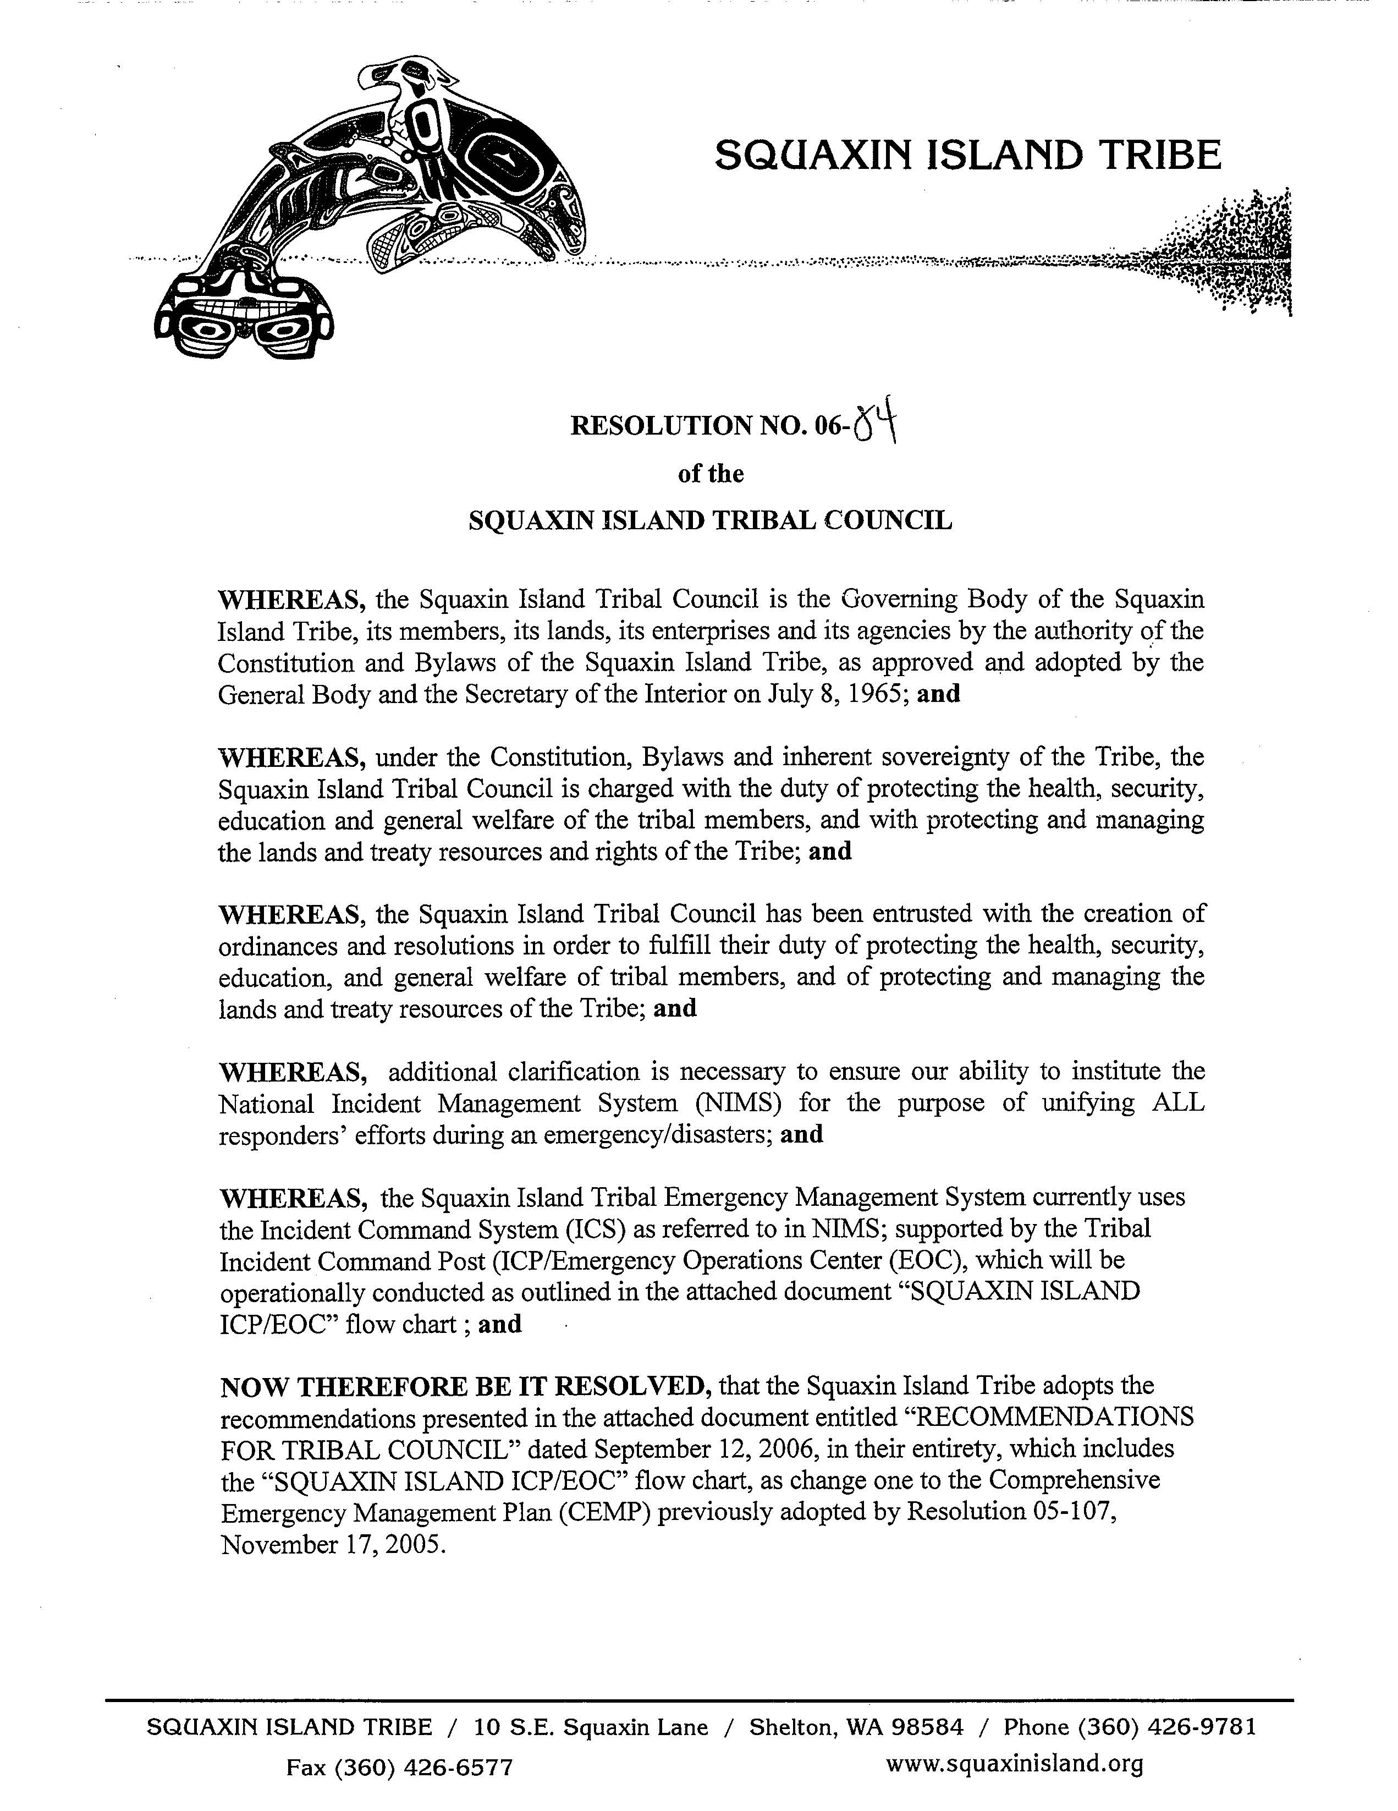
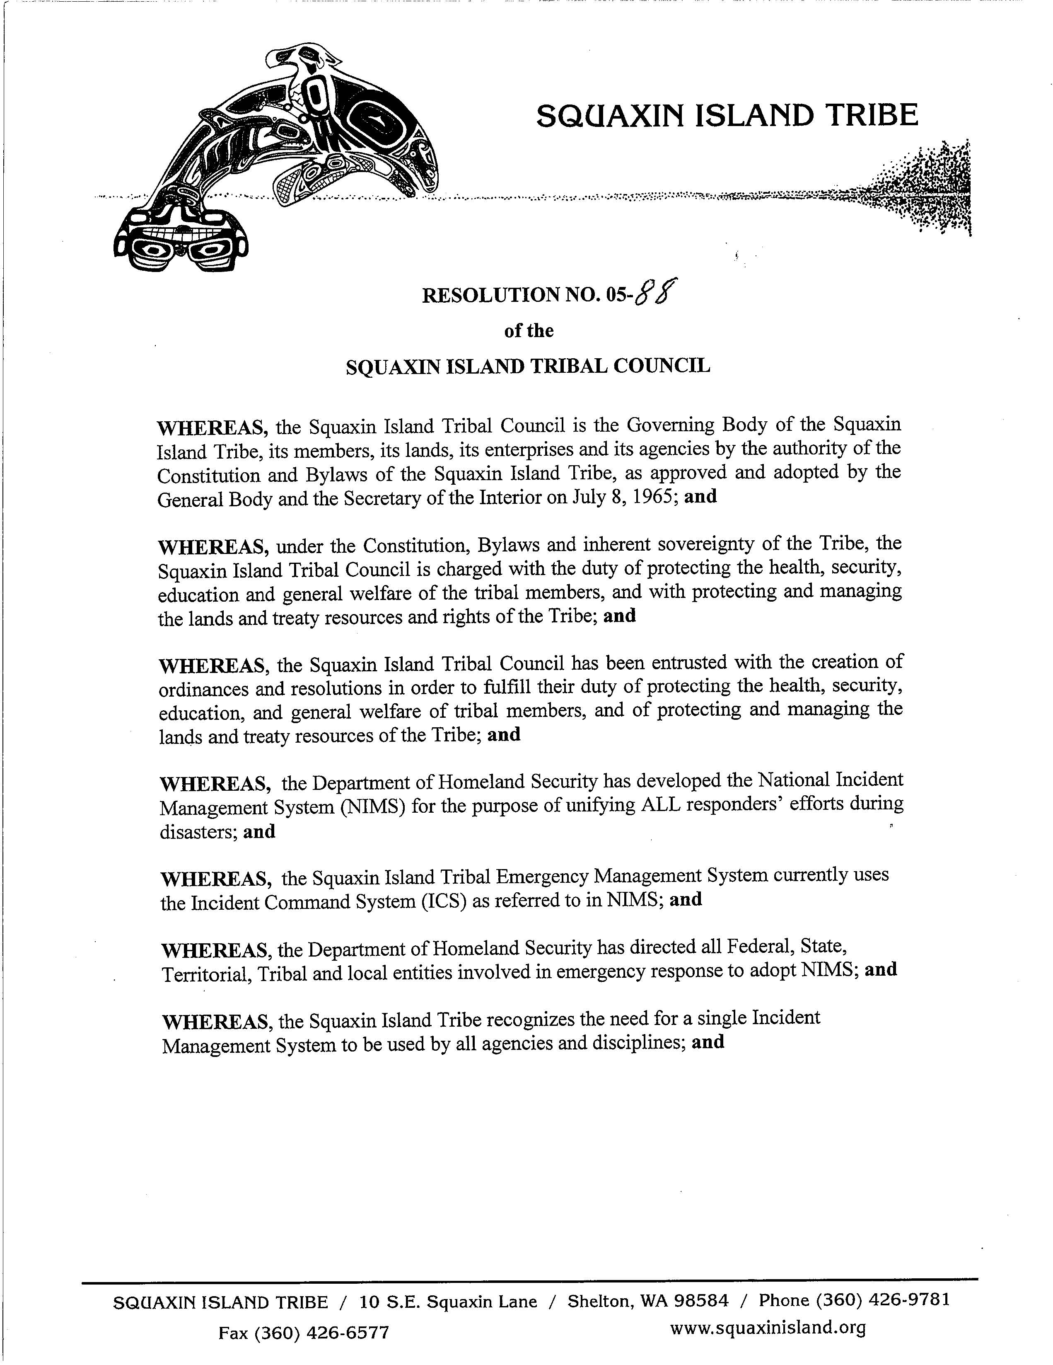
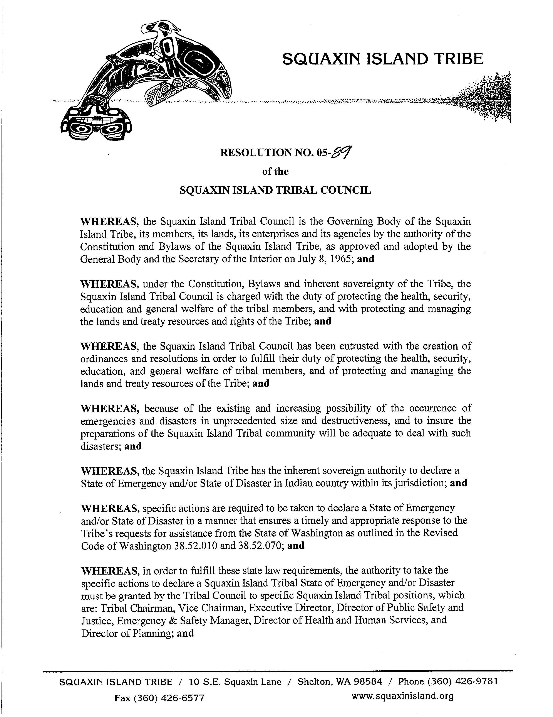
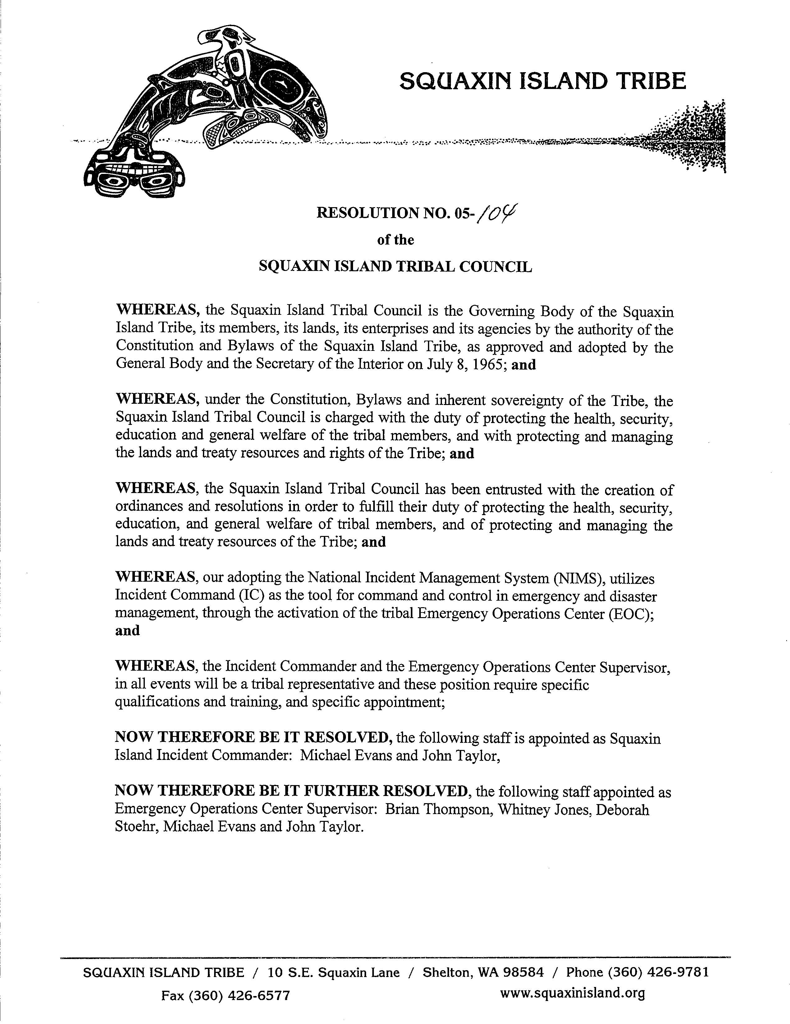
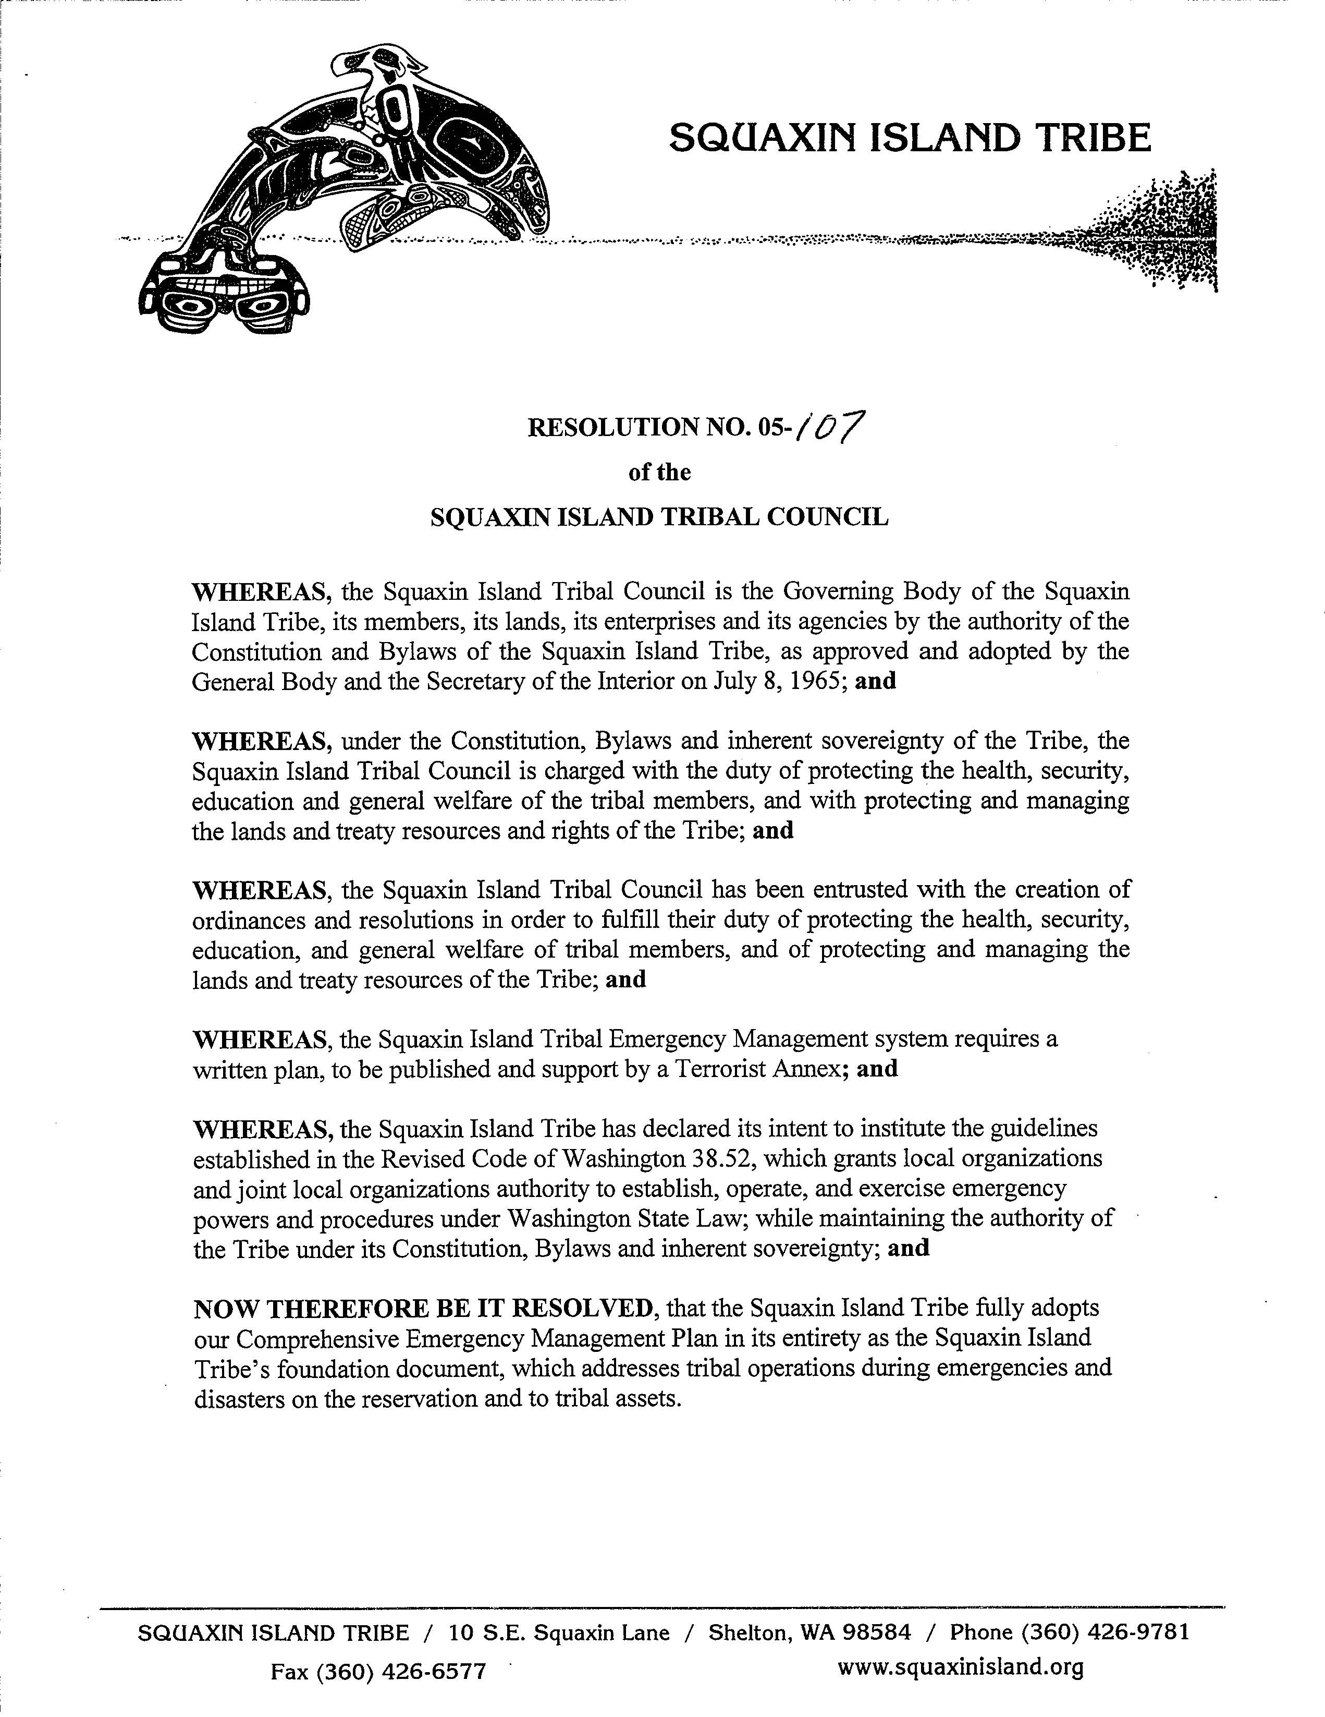

APPENDIX C
SUPPORTING PLANS

APPENDIX D
EXAMPLE: POTENTIAL ACTIONS TAKEN FOR AN INCIDENT

The National Weather Service is reports that a severe weather storm is expected to impact our area within the next 48 to 72 hours. We can expect high winds, rain turning to sleet at times, and is predicted to remain in effect for approximately 12 hours.

PRE-INCIDENT (See VI, A – Event and Pre-Incident Planning and Preparedness)

- Area Commander (AC) is assigned based on the qualified staff member that is scheduled on-call during this time period.

-Specific administrative actions are taken
1.Incident Number Assigned and electronic folder created
2. Tribal Incident Form Started
3. Communication Log Started and updated
4. IAP started
5. After Action Review Started
-Will identify an IC both from tribal government and coordinate Mason County Fire District 4 (MCFD#4)
-AC will contact the Tribal Incident Management Team (TIMT) and schedules a Pre-disaster Operations meeting, ASAP. This group will identify the sections (ACO/ICP/EOC) who will placed on Stand-by and those placed On-Call; additional supervisors will be identified; all Emergency Contracts pertinent are identified and assigned to a staff member to begin coordination with those vendors.
-A Tribal IAP will be more developed with the assistance of the TIMT and will develop the Communications Plan.
-AC will contact State EMD and initiate WebEOC and provide them the Tribal Incident Number.
-Once the TIMT meets the AC will:
1. Email all tribal government and inform them of all the information to date; identify those resources assigned under ICS and EOPs; release those resources back to SOP.
2. Schedule the initial briefing with the ICS/Sections and brief the IAP.
3. Institute the Communications Plan, which includes issuing radios and providing communications protocols.
4. Recovery Team is identified and priorities established
-Conduct operational briefing with identified staff where:
1. IAP will be better developed
2. Safety issues addressed
3. Communications plan presented and equipment issued
4. Response protocols are developed by the group
-TIMT is briefed on all actions taken and developed to date. The Electronic Incident Folder is made available to identified staff.
-AC publishes their location during the incident (ACO/ICP/EOC)

RESPONSE

WHEN THE INCIDENT OCCURS ADDITIONAL ACTIONS WILL BE TAKEN BASED ON THE TYPE AND MAGNATUDE OF THE INCIDENT.

-All Activates will be in compliance with ICS and document per ICS guidelines.
-No responding assets are released until authorized by the AC or IC when authority is transferred from the AC to IC.
-Actions taken during Pre-Incident are expected to be completed ASAP after an initial incident that is unexpected.

ALL ACTIVITIES DURING PRE-INCIDENT PLANNING AND DURING RESPONSE, WILL SUPPORT RECOVERY

APPENDIX E

SQUAXIN ISLAND ICP/EOC

TRIBAL ICP/EOC
[Joint Location]

IC
Executive
Services
Deputy IC/EOC Sup

PIO

Legal
Staging Area
Heliport/Spots
Base/Camp
ICP
EOC
Finance/Admin
Logistics
Plans
Coordination
Communications
Resource
Management
Information
Management
Dir Finance
Section Chief
DCD/Plans
Section Chief
Dir NR
Section Chief
DCD/Plans
Section Chief

IS
Section Chief
Dir Health
Section Chief
Human Resources
Finance
NR
Com. Dev.
Planning
Child Dev
Construction
Island Ent
Legal Serv
HR
IS
PIO
Exec. Serv.
NWITC
Public Safety
Exec. Serv.
Admin
Learning Cnt
Cultural Res
Little Creek
Public Safety
MCFD 4

PRIMARY SECTION CHIEFS-Are those departments in highlighted in RED. The Primary Section Chiefs are responsible for ensuring those departments below them are trained and prepared; this includes creating and publishing Section EOPs.

APPENDIX F
EMERGENCY SUPPORT FUNCTIONS
PARTICIPATING AGENCY RESPONSIBILITIES MATRIX
TRIBAL ASSETS | 1 - TRANSPORTATION | 2 – COMMUNICATIONS | 3 – PUBLIC WORKS & ENGINEERING | 4 – FIREFIGHTING | 5 – EMERGENCY MANAGMENT | 6 – MASS CARE, HOUSING, & HUMAN SERCIICES | 7 – RESOURCE SUPPORT | 8 – HEALTH & MEDICAL SERVICES | 9 – SEARCH & RESCUE | 10 – OIL & HAZARDOUS MATERIALS RESPONSE | 11 – NATURAL RESOURCES | 12 – ENERGY | 13- PUBLIC SAFETY & SECURITY | 14- LONG-TERM RECOVERY & MITIGATION | 15- EXTERNAL AFFARIS | 16– ELDERS & THE DISABLED | 17– EVACUATION & MOVEMENT | 18 - GOVERNMENT-TO-GOVERNMENT (MUTUAL AID, DISASTER ASSISTANCE)

ALL ASSETS
Child Development Center  RESORUCE SECTION |  |  |  |  | S | S
Community Dev. & Planning  PLANNING/COORD. SECTION | P |  | P |  | S | S | S |  | S | S | S | P |  | S | S | S | P
Cultural Resources  RESOURCE SECTION |  |  |  |  | S
Emergency & Safety Management (ICS CMD) | S | S | S | P | P | S | P | S | S | S | S | S | S | P | S | P | P | S
Finance  FINANCE SECTION | S | S | S | S | S | S |  | S | S | S | S | S | S
Health & Human Services  RESOURCE SECTION |  | S | S |  | S | P | S | P | S | S | S |  | S | S | S | S | S | S
Human Resources  INFORMATION SECTION | S |  | S |  | S | S | S | S | S | S | S |  |  | S | S | S | S | S
Information Services  COMMUNICATIONS SECTION | S | P | S | S | S | S | S | S | S | S | S |  | S | S | S | S | S | S
Island Enterprises  RESOURCE SECTION |  |  |  |  | S | S
Legal  INFORMATION SECTION | S | S | S | S | S | S | S | S | S | S | S | S | S | S | S | S | S | S
Little Creek Casino/Resort  RESOURCE SECTION |  |  |  |  | S | S
Museum, Library, & Research Center RESOURCE SECTION |  |  |  |  | S | S
Natural Resources  LOGISTICS SECTION | S | S | S | S | S |  | S |  | S | P | P | S |  | S | S |  |  | S
NWITC  COORDINATION SECTION |  |  |  |  | S | S
Public Safety & Justice  COORDINATION SECTION | S | S | S | S | S | S |  | S | P | S | S | S | P |  |  | S | S
Tribal Administration (Exec.)  INFORMATION SECTION | S | S | S | S | S | S | S | S | S | S | S | S | S | S | P | S | S | P
Tribal Gaming Authority  COORDINATION SECTION |  |  |  |  | S
Learning Tu Ha’Buts Learning Center RESOURCE SECTION |  |  |  |  | S

LEGEND:

P: Primary Responsibilities
S: Supporting Responsibilities

Appendix G
OPERATIONAL PLANNING GUIDELINES

Executive Group Planning Guidelines
The Tribal Council and Executive Director will approve all appointments of Tribal Incident Commanders, who will serve on a rotating basis, ready to respond to emergencies 24 hours a day, seven days a week, to include holidays. The Incident Commander will carry cellular/satellite telephone, and have at their disposal a laptop computer at all times during their on-call scheduled duty to ensure there is a point of contact in an emergency. If the On Call Incident Commander must leave the immediate area, they will ensure that the duty is transferred to another member, who is qualified, during their absence. The duty roster and contact number will be posted and published on the tribal website, JURISDICTION DEM, and WA State EMD/EOC for use in emergency situations only (or as determined by the Executive Group).
The On Call Incident Commander will have primary responsibility for Executive response to an emergency, as well as for the following communications (as deemed appropriate):
- Notify Executive Team
- Activate the EOC
- Declare A Formal Disaster
- Establish communications with assisting/supporting organizations
On Call Area Commander (AC) / Incident Commander (IC)
- Primary contact for all incidents on Tribal property and to Tribal assets.
- Respond to Tribal Emergency Operations Center (or assume control on the incident site when appropriate)
- Activate appropriate calling tree(s)
- Remain on active cell-phone for Incident updates
- Ongoing Responsibilities:
  - Communication Link (Financial decisions (procurement, personnel, overtime) until EOC is activated.
- Mobilization of Disaster Communications Centers as required
- Determine w/EOC Supervisor demobilization of EOC/SOC
- Assist in recovery efforts
- Determine scope and impact, directs communication on scope (in consultation with EOC Supervisor)

Appendix H
Implementation Plan
How do we get Tribal (various constituents) to “buy in”?
- Buy in session for Tribal Assets
- Presentation to and by Department Heads
- Department Meetings
How to clear up any resulting confusion?
- Who key personnel (essential) are?
- Do I come in or not?
Leadership support … top to bottom essential
Communication and education are keys
Workload (department plan development) vs. priority
- Everyone already overworked
Liabilities/Insurance impact on buy-in
- Personal versus Tribal liability
Buy-in -- Who?
- Directors and Managers
- Executive Group
- Tribal members
- Community (OEM, Fire Dept., Police Dept., Utilities)
- Mayor/City Manager
- Other related
How?
- Executive Group
- Presentations – with video, by building, by org.?
- Who goes to which group?
- Dept plan based on template (web based)
- Time frame (six months)
- Liaisons for assistance in plan development
- Ex. Group advice & assistance in plan develop

Appendix I
Planning and Training
CEMP
- A Tribal Course will be developed (SI-EM-100), which will inform tribal staff on the Emergency Management System (Federal, State, Tribal, Local), including Emergency and Disaster Management at the tribe.
- The CEMP will be reviewed at-least every four years, correction made if necessary, and submitted to the State of Washington.
- Departmental Emergency Operation Plans (EOP) will be developed, trained to departmental staff, which includes new hires and assigned staff. Each staff member will understand their response requirement based on the categories of Tribal Responders and the needs of their department.
- Emergency Responders will be required to support all training efforts that require the activation of the EOC.
- All First and Emergency Responders will complete the established training requirements outlined for Critical Staff in NIMS/ICS.
- Disaster Reservist will receive SI-EM-100 and ICS-100 and any other training determined necessary by their departments.
CONSIDER THE FOLLOWING:
-Staff (when, how, who?)
-Filter from top to bottom (make it important!)
-Department plan coordinates with Tribal plan
- How relates to department?
- How relates to community?
-Inside vs. Outside emergency
-Mark stairs, exit vs. elevator
-Department Emergency Coordinator
- Trained by EM & S Manager
- Must be mandatory
- Enforced by Executive Group
- Like affirmative action or sexual harassment

Appendix J

Testing and Evaluation Process
- All plans will be reviewed annually, and tested by department, which will include a tribal tabletop.
- All exercises will be documents and consist of an After-Action-Review, and time-line for recommended changes.
- The tribe will establish a testing and evaluation process as outlined by the Department of Homeland Security. This will be effective FY-07. Due to a Full Scale Exercise being conducted on October 18, 2006.
- Changes to the CEMP require a review of all departmental EOPs to ensure each continues to support the other. At the completion of the review a Tribal Tabletop will be conducted as soon as possible.
- Changes to Departmental EOPs require being reviewed by the Emergency Manager and the Emergency Management/Homeland Security Committee. Once approve a Departmental Tabletop will be conducted, overseen by the Emergency Manager. If a departmental change impacts other departments, it is the responsibility of the Departmental Director to coordinate and ensure the effected departments participate in the Departmental Tabletop.
- The Squaxin Island Tribe will institute a Continuous Improvement Process as indicated below.

Appendix K
CONTINOUS IMPROVEMENT PROCESS
Provide Management Commitment & Leadership
System Elements
Assess-Establish a Baseline
Plan-Set Goals, Strategies, and Tactics
Improve-Strategies and Tactics

Review and Adjust

Appendix L

Tribal Implementation of WA State Sponsored
WebEOC

WebEOC is software that is sponsored by the State of Washington, Emergency Management Division (EMD), which is designed to bring real-time crisis information management to the Washington State Emergency Operations Center (EOC) and those partnering EOCs as well as other state and federal EOCs.

SQUAXIN ISLAND TRIBE
WebEOC
Organizational Flow Chart

General Council
Executives
WebEOC
Administrator
Incident Commander
Recovery Commander
EOC Supervisor
ROC Supervisor
PIO

EM Responders
Fire, Law, EMS
Support Services

Finance/Admin

Logistics

Plans/Policies

Incident Mng. (Commo)
Recovery Mng.
Mason County
Liaison

Blue-Emergency/Disaster Recovery
ROC-Recovery Operations Center

Appendix M

Plan Maintenance Time-Table

BASE COMPREHENSIVE EMERGENCY MANAGEMENT PLAN (CEMP)- Is the governing document for which the Squaxin Island Tribe will conduct emergency and disaster operations. This plan will be maintained by the Tribal Emergency and Safety (EM&S) Manager, complying with the following time-line:

  - Tribal Council review will occur every two years, established by the adopting of this document by the Tribal Council.
  - Corrections and recommendations for change will be collected by the EM&S Manager and reviewed by the Emergency Management/Homeland Security (EM/HS) Committee.
  - All changes supported by the EM/HS Committee will be placed on a master sheet, which will include why they are recommended (Example: Meets Tribal Operational Procedure).
  - Six months prior to the final review date, the EM&S Manager is publish a review schedule, which will be provided to departmental managers and the Tribal Council.
  - The revised CEMP will be provided to all Tribal Council Members, 90 days in advance of the final review date and adoption.

MITIGATION SECTION- The Squaxin Island Tribal Mitigation Plan is a joint document with JURISDICTION, City of Shelton, Mason General Hospital, JURISDICTION Fire Protection Districts 2 and 5, adopted December 2004.

- The initial Hazard Mitigation Plan assessment and review will be conducted 2 years after the Plan has been formally adopted. (12/06)
- Thereafter, the Hazardous Mitigation Plan will be conducted every 5 years to coincide with the review of the CEMP (12/11)

PREPAREDNESS SECTION- CURRENTLY UNDER DEVELOPMENT

EMERGENCY AND DISASTER MANAGEMENT- This Section consists of the tribal departmental, asset, and enterprise Emergency Response Plans required within this document:

- Initial departmental, asset, and enterprise draft plans are required within 6 months of the date this CEMP is adopted.
- Final plans are due within 90 days from the submission of the draft plan. Final plans consist of (1) a published document signed by the authority; (2) certification by that authority contesting to the completion of required staff training and an organizational tabletop performed; (3) a completed EOC reference manual outlining their function during activation.

NOTE: ALL EOPs ARE THE DIRECT RESPONSIBILITY OF THE DIRECTORS AND MANAGERS, AND ARE NOT REQUIRED TO BE REVIEWED BY THE TRIBAL COUNCIL. THEY WILL BE SUBMITTED AND REVIEWED BY THE EM&S MANAGER. REPORTS WILL BE FILED PERODICALLY TO THE TRIBAL COUNCIL ON THE STATUS OF THIS DOCUMENTS.

Appendix N
Squaxin Island Tribe
Continuity of Government
Emergency and/or Disaster

In the order shown the following tribal positions have full authority to take any actions necessary to protect people, property, the environment, and economy. The order of secession occurs as outlined in this CEMP; II. POLICIES; B. Continuity of Government.

Tribal Council

Executive Director

Deputy Executive Director

Tribal Coordinating Officer (TCO)

Area Commander

Incident Commander (If the appointed person is a tribal staff member)

Deputy Incident Commander/EOC Supervisor

Finance and Administration Section Chief

Planning and Coordination Section Chief

Logistics Section Chief

Information Section Chief

Communications Section Chief

Appendix O
INCIDENT TYPES
U.S. FIRE ADMINISTRATION
(Type 5 Least Complex – Type 1 Most Complex)

TYPE 5:

- The incident can be handled with one or two single resources with up to six personnel.
- Command and General Staff positions (other than the Incident Commander) are not activated.
- No written Incident Action Plan (IAP) is required. The incident is contained within the first operational period and often within an hour to a few hours after resources arrive on scene.
- Examples include a vehicle fire, an inured person, or a police traffic stop.

TYPE 4:

- Command staff an general staff functions are activated only if needed.
- Several resources are required to mitigate the incident, including a Task Force or Strike Team.
- The incident is usually limited to one operational period in the control phase.
- The agency administrator may have briefings, and ensure the complexity analysis and delegation of authority are updated. (
- No written Incident Action Plan (IAP) is required but a documented operational briefing will be completed for all incoming resources.
- The role of the agency administrator includes operational plans including objectives and priorities.

TYPE 3:

- When capabilities exceed initial attack, the appropriate ICS positions should be added to match the complexity of the incident.
- Some or all of the Command and General Staff positions may be activated, as well as Division/Group Supervisor and/or Unit Leader level positions.
- A Type 3 Incident Management Team (IMT) or incident command organization manages initial action incidents with a significant number of resources, an attack incident until containment/control is achieved, or an expanding incident until transition to a Type 1 or 2 team. (In compliance with the CEMP).
- The Incident may extend into multiple operational periods.
- A written IAP may be required for each operational period.

TYPE 2:

- The type of incident extends beyond the capabilities for local control and is expected to go into multiple operational periods. A Type 2 Incident may require the response of resources out of area, including regional and/or national resources, to effectively manage the operations, command, and general staffing.
- Most or all of the Command and General Staff positions are filled.
- A written IAP is required for each operational period.
- Many of the functional units are needed and staffed.
- Operations personnel normally do not exceed 200 per operational period and total incident personnel do not exceed 500 (guidelines only).
- The agency administrator is responsible for the incident complexity analysis, agency administrator briefings, and the written delegation of authority.

TYPE 1:

- This type of incident is the most complex, requiring national resources to safely and effectively manage and operate.
- All Command and General Staff positions are activated.
- Operations personnel often exceed 500 per operational period and total personnel will usually exceed 1,000.
- Branches need to be established.
- The agency administrator will have briefings, and ensure that the complexity analysis and delegation of authority are updated.
- Use of resource advisors at the incident base is recommended.
- There is a high impact on the local jurisdiction, requiring additional staff for office administrative and support functions.

NOTE: THIS IS A GUIDELINE PUBLISHED BY THE U.S. FIRE ADMINISTRATION. THESE GUIDELINES DO NOT REPLACE THE REQUIRED ACITIONS REQUIRED BY THE TRIBAL COMPREHENSIVE EMERGENCY MANAGEMENT PLAN (CEMP).

Appendix P
EMERGENCY AND DISASTER ASSISTANCE COMPACT
BETWEEN
Squaxin Island Tribe
&
Jurisdiction

- Article I: Preamble
- Article II: Emergency Responders Defined
- Article III: Participating Signatories Responsibilities
- Article IV: Implementation
- Article V: Limitations
- Article VI: License, Certificate and Permit Portability
- Article VII: Reimbursement, Disputes Regarding Reimbursement
- Article VIII: Development of Guidelines and Procedures
- Article IX: Workers' Compensation
- Article X: Immunity
- Article XI: Severability

Article I Preamble
The purpose of this agreement is to create a system of mutual aid between the Squaxin Island Tribe and JURISDICTION. Each participant of this system recognizes that emergencies transcend political jurisdictional boundaries and that intergovernmental coordination is essential for the protection of lives and property and for best use of available assets both public and private. The system shall provide for mutual assistance among the participating signatories in the prevention of, response to, and recovery from, any emergency/disaster that results in a formal state of emergency in the participating signatories, subject to that participating member’s criteria for declaration. The system shall provide for mutual cooperation among the participating subdivisions in conducting disaster related exercises, testing or other training activities outside actual declared emergency periods. This agreement provides no immunity, rights or privileges for any individual responding to an emergency that is not requested and/or authorized to respond by a participating political subdivision. Participating signatories will be ensured, to the fullest extent possible, eligibility for state and federal disaster funding.
All signatories enacting of this agreement, are automatically a part of the this mutual aid system. Any political subdivision within this agreement may elect not to participate or to later withdraw from the system upon enacting an appropriate resolution by its governing body declaring that it elects not to participate in this mutual aid system; and providing a copy of the resolution to the signatories. These actions do not preclude participating signatories from entering into supplementary agreements with another political subdivision and does not affect any other agreement to which a political subdivision may currently be a party to, or decide to be a party to.
Article II Emergency Responders Defined Emergency Responders Defined
An emergency responder is defined as anyone with special skills, qualifications, training, knowledge and experience in the public or private sectors that would be beneficial to a participating political subdivision in response to a locally declared emergency as defined in any applicable law or ordinance or authorized drill or exercises; and who is requested and/or authorized to respond. Under this definition, an emergency responder may or may not be required to possess a license, certificate, permit or other official recognition for their expertise in a particular field or area of knowledge. An emergency responder could include, but is in no way limited to, the following: law enforcement officers, fire fighters, emergency medical services personnel, physicians, nurses, other public health personnel, emergency management personnel, public works personnel, those persons with specialized equipment operations skills or training or any other skills needed to provide aid in a declared emergency.
Article III Participating Signatories Responsibilities
It shall be the responsibility of each participating political subdivision with jurisdiction over and responsibility for emergency management within that certain subdivision to do the following:
- Identify potential hazards that could affect the participant using an identification system common to all participating jurisdictions.
- Conduct joint planning, intelligence sharing and threat assessment development with contiguous participating signatories, and conduct joint training at least biennially.
- Identify and inventory the current services, equipment, supplies, personnel and other resources related to planning, prevention, mitigation, response, and recovery activities of the participating political subdivision.
- Adopt and put into practice the standardized incident management system approved by each of the signatories.
Article IV Implementation
A participating political subdivision may request assistance of other participating signatories in preventing, mitigating, responding to and recovering from disasters that result in locally-declared emergencies or in concert with authorized drills or exercises as allowed under this agreement. Requests for assistance shall be made through the chief executive officer of a participating political subdivision or his designee. Requests may either be verbal or in writing. Verbal requests will be followed up with a written request within 24 hours of the verbal; or if longer, as agreed upon by the interested parties.
Article V Limitations
A participating political subdivision's obligation to provide assistance in the prevention of, response to and recovery from a locally-declared emergency or in authorized drills or exercises is subject to the following conditions:
- A participating political subdivision requesting assistance must have either declared a state of emergency in the manner outlined in Article I or authorized drills and exercises.
- A responding participating political subdivision may withhold resources to the extent necessary to provide reasonable protection and services for its own jurisdiction.
- Emergency response personnel of a responding participating political subdivision shall continue under the command and control of their responding jurisdiction to include medical protocols, standard operating procedures and other protocols, but shall be under the operational control of the appropriate officials within the incident management system of the participating political subdivision receiving the assistance.
- Assets and equipment of a responding participating political subdivision shall continue under the control of their responding jurisdiction, but shall be under the operational control of the appropriate officials within the incident management system of the participating political subdivision receiving the assistance.
Article VI License, Certificate and Permit Portability
If a person or entity holds a license, certificate or other permit issued by a participating political subdivision or the state evidencing qualification in a professional, mechanical or other skill and the assistance of that person or entity is requested by a participating political subdivision, the person or entity shall be deemed to be licensed, certified or permitted in the political subdivision requesting assistance for the duration of the declared emergency or authorized drills or exercises and subject to any limitations and conditions the chief executive of the participating political subdivision receiving the assistance may prescribe by executive order or otherwise.
Article VII Reimbursement, Disputes Regarding Reimbursement
Any requesting political subdivision shall reimburse the participating political subdivision rendering aid under this system within 45 days from the return of resources. A participating political subdivision providing assistance may determine to donate assets of any kind to a receiving participating political subdivision. Such requests for reimbursement shall be in accordance with procedures developed by the signatories to this agreement.
Should a dispute arise between parties to the system regarding reimbursement, involved parties will make every effort to resolve the dispute within 30 days of written notice of the dispute by the party asserting noncompliance. In the event that the dispute is not resolved within 90 days of the notice of the claim, either party may request the dispute be solved through arbitration. Any arbitration under this provision shall be conducted under the commercial arbitration rules of the American Arbitration Association.
Article VIII Development of Guidelines and Procedures
Comprehensive guidelines and procedures will be develop to address, including but not limited to, the following: projected or anticipated costs, checklists for requesting and providing assistance, record keeping for all participating signatories, reimbursement procedures and other necessary implementation elements along with the necessary forms for requests and other records documenting deployment and return of assets.
Article IX Workers' Compensation
Personnel of a participating political subdivision responding to or rendering assistance for a request who sustain injury or death in the course of, and arising out of, their employment are entitled to all applicable benefits normally available to personnel while performing their duties for their employer. Responders shall receive any additional state and federal benefits that may be available to them for line of duty deaths.
Article X Immunity
All activities performed under this agreement are deemed hereby to be official functions. For the purposes of liability, all persons responding under the operational control of the requesting political subdivision are deemed to be employees of the requesting participating political subdivision. Neither the participating signatories nor their employees, except in cases of willful misconduct, gross negligence or bad faith shall be liable for the death of or injury to persons, or for damage to property when complying or attempting to comply with this mutual aid system.
Article XI Severability
Should a court of competent jurisdiction rule any portion, section or subsection of this legislation invalid or nullified, that fact shall not affect or invalidate any other portion, section or subsection; and all remaining portions, sections or subsections shall remain in full force and effect.

Checklist of Best Practices
- Closely tie legislation/agreement to EMAC member states' legislation and SOP's for seamless escalation of disaster response and execution of mutual aid.
- Encourage participation by a broad range of emergency responders. Include other definitions as appropriate. Consider global perspective, e.g., public works, private entities, medical personnel, public transportation and others.
- Make legislation opt-out. Most states have several hundred municipalities and other jurisdictions within their borders. To attempt to get everyone on board on an opt-in agreement could take years and never achieve a plurality of participation. By making legislation opt-out, everyone is a part of the system the day it becomes law.
- To the extent permitted by applicable law, include automatic renewal language if agreement instead of legislation.
- Agreements/legislation should mandate joint planning, training and exercise with liability immunity as if it were an actual emergency.
- Develop forms to facilitate requests for aid, record-keeping regarding movement of equipment and personnel and reimbursement.
- Require use of a standardized incident command/management system consistent with that used by the state.
- In addition to not affecting any existing agreements, should also allow for supplemental agreements between participants.
- Have a liability/immunity article.
- Consider arbitration of disputes concerning reimbursement.
- Be as concise as possible. Guidelines and procedures should be developed separately, but become part of the legislations/agreement when adopted.
- Establishment of a committee representative of all emergency preparedness and response disciplines and other stakeholders to examine continual changes in emergency preparedness and insure legislation/agreements meet the needs of disciplines/stakeholders. Committee may have standing and authority to refer needs to legislature for rectification. Consider existing committees representative of all stakeholders to determine if they may perform this function.
- A reimbursement provision. This provision may include an off-set for any insurance proceeds applicable to the costs claimed by the responding political subdivision. The insurance claims process should not delay reimbursement. Reimbursement shall not duplicate any state or federal assistance available for the costs.

MUTUAL AID PARTNERS LIST

APPENDIX Q

EMERGENCY OPERATIONS Planning (EOP) Guide

During a Level 2 and 3 Emergency, Group members provide support on a case-to-case base and as requested by the AC/IC. Those Group members indicated by (*) will be expected to respond for Level 2 emergencies. All Group members would be required to respond to all Level 1 emergencies. Additional personnel may be assembled as required for specific emergency conditions.
Each department will develop a Departmental Emergency Plan to address emergency staffing, emergency contacts, and contingency planning. Each unit provides advice to assist in developing tribal contingency plans in anticipation of emergencies, as well as to recover from the impact of the emergency. Units will also assemble for post – incident recovery operations. Units/departments marked (*) will provide designated representatives to the EOC.
SPECIFIC FUNCTIONS AND ACTIVITIES:
Police – the Department of Public Safety/Tribal Police are trained and certified to respond to a wide variety of criminal activities. Some responses may also require the assistance of the local Police agencies to provide backup, supplemental, or specialized Police functions. The decision to bring in external law enforcement support is at the sole discretion of this department.
Safety – The Tribal Emergency Manager is designated and trained to provide proper response to chemical and environmental emergencies within the capabilities of Tribal resources, acts as the chemical/environmental emergency advisor to the AC/IC, functions as an TCO/AC/IC, and/or the EOC Supervisor and may liaison, as required, with external agencies to mitigate, control, and recover from an emergency/disaster.
Medical – there is not a trained medical emergency response team for the Tribe, so response to medical emergencies will be routed through the 911 dispatcher as necessary. In the event of a disaster this plan will be activated.
Public Works – coordination of Tribal grounds, facilities, vehicles, and Tribal specific utilities services at the scene of the emergency will be coordinated through the Director of Planning.
Fire – there is not a trained fire response team for the Tribe, so all fires fall under the jurisdiction of JURISDICTION TCFD1. Upon their response on Tribal Property and/or to a Tribal asset, an AC will be established and the will be a Tribal Representative. In the event an IC is necessary, the AC can appoint the IC from TCFD1, complying with ICS. When transitioning from Response to Recovery, the AC will retain responsibility for direct communication with the appropriate parties, until other instructions are issued by the Executive Group.
Hazardous Materials – significant hazardous materials event, which are beyond the capability or qualification of Tribal resources, require specialized response from the appropriate department and/or agency. Hazardous Material events that result in a release or potential release into the environment may also require the assistance of the Washington State EOC, who coordinates a State response. During the response to and containment of hazardous materials incidents, the Tribal AC/IC will coordinate all responding agencies and/or departments to include HAZMAT Unit. The HAZMAT Unit Commander will closely liaison with the AC/IC to coordinate a safe and efficient response and maximize available resources. The AC/IC will retain responsibility for direct communication with the EMHSC, and has the authority to suspend any Tribal Operations and order an evacuation of any tribal asset to protect people, property, and the environment.
WHEN ACTIVATED, THE FUNCTIONS BELOW, WILL BE FORMALLY ASSIGNED TO SPECIFIC SECTIONS WITHIN TRIBAL GOVERNMENT; AND THE ADMINISTRATION TRANSFERRED TO THE APPROPRIATE SECTION WITHIN THE ACO/ICP/EOC.
Utilities – in some incidents (e.g. involving natural gas, electrical, public water, and sewer) The Director of Planning and the appropriate Tribal Sections, will coordinate or provide specialized support directly related to the control of utility services (i.e. shut off and reestablishing), and recovery from utility outages. However, any extended period of time (24+ hours) without a utility constitutes a State of Disaster.
Transportation services may be required for relocation, movement of emergency response personnel, and other aspects of emergency containment and recovery. Contingency plans must be developed to prepare for efficient allocation of available vehicles. The coordination of transportation services will be the responsibility of the AC/IC supported by the Resource Management Section Chief.
Information Services (IS) (*) will provide communications via cellular telephones, computer networks, and radios for all operations. In addition, IS will support the assessment of damage to Tribal computer stations and assets, record damage and restoration via film for insurance and historical purposes, and assist in establishing external communication links, e.g. telephone or off-tribal computer networks.
Counseling services will advise the AC/IC and will provide trauma counseling for affected members of the Tribal community. A representative of the Counseling Center will report to the EOC for all Level 2 and 3 emergencies, and may be contacted, as appropriate, for some Level 1 emergencies.
Plans (*) are a resource that may be required for affected buildings and areas of the Tribe to properly manage or control the incident. The Director of Planning and DCD will provide staffing or other support to respond to this need as required for all levels of emergency response. These plans will be made available at the EOC for Level 1 and 2 emergencies.
The Director of Health and Human Services (*) is a required resource for the EMHSC to provide professional knowledge related to medical issues. Emergency Medical Services may be provided by these tribal resources, but only when:
- In accordance with standard operating procedures, or as prescribed in the department Emergency Operations Plan.
- Determined by the Confederated Tribes Of the Chehalis to be necessary. These activities will be coordinated through either the AC, ACO, or the EOC.
- Area Command Operations (ACO) will consist of finance and Administration, Planning, and Logistics.
- The EOC will provide the 4 functions; Coordination, Communications, Resource Management, and Information Management.
Documentation (*) must include, all costs accumulated throughout the emergency in order to file for recovery. As the scope of the emergency increases, so do the costs and the difficulty in properly recording them. Costs may include direct and indirect personnel expenses, vehicle and heavy equipment charges, supply and equipment purchases, contract and lease fees, and the like. It is essential that personnel assignments to the EOC include specific responsibility to account for these costs. Tribal Accounting will direct Administration and Finance and determine which Departmental Emergency Plan(s) will include these requirements and procedures. Additional documentation will include logging of events, activities, media releases, and other essential information for full reconstruction of the event after the fact. All departmental plans will be part of the Section EOPs.
Facilities (*) across the Tribe may be affected by the emergency, regardless of the level or extent. Of course, the more serious the emergency, the more facilities and associated support will be required. Each unit, Tribal Asset, and department shall include in their EOP for securing, evacuating, and recovering all facilities within the scope of their responsibility. Physical Plant planning must also include processes for providing essential support services, and personnel to assist the Incident Commander as required. The appropriate Section will report to the EOC for Level 2 and 3 emergencies in order to coordinate with the EMHSC.
Food Service (*) [When Assigned] may be required to support emergency response personnel, the EMHSC, EOC, and supporting units. In some cases individuals may be stranded at Tribal Assets as the result of a regional emergency (e.g. blizzard), and may require food service. Contingency plans shall include provisions for providing this service from Tribal Assets to the maximum extent feasible or to coordinate such services with outside agencies. (Coordinated by the EMHSC and Emergency Manager)
Housing (*) [When Assigned] or sleeping facilities may be required to provide either respite for emergency response personnel or shelter for stranded individuals. Plans should be prepared to include both times when tribal assets may or may not be available. (Coordinated by Emergency Manager).
Claims will normally be filed for insurance recovery or protection. Much of the information required for these claims must be adequately documented during the course of the emergency and properly submitted in the recovery phase. All Emergency Processes will comply with State (RCW 38.52) and FEMA standards (Stafford Act), which will facilitate cost recovery guidelines established by both Washington State and the Federal Government.
Procurement (*) of equipment, supplies and support services, in compliance with RCW 38.52 (Disaster Declaration), may require emergency contracts or provision for on-call resources; and will comply with ICS is the responsibility of the Accounting Section.
Health and Human Services should anticipate the needs of individuals with physical and mental limitations, to include Tribal Elders, in response to a variety of emergencies. Review of Department Emergency Plans and related emergency procedures shall include verification that the disabled are neither endangered nor neglected in emergencies. Has the ability to authorize a Quarantine in part or whole tribal assets to protect community health.
Personnel (*) resources may be stretched to the limits. Full documentation and settlement of pay issues, and staff augmentation or personnel services contracts all may be required. When determined necessary the Tribal Disaster Reservists will be activated.
Copying Services (*)[When Assigned] may be required to provide multiple, short – notice documents in support of both emergency management and recovery operations; in compliance with ICS.
Tribal Legal (*) will be required to minimize the impact of the emergency and enhance recovery efforts; and are assigned to the Information Management Section (Appendix D).
Finance may need to be prepared to provide assistance with short -term, creative methods to “take care of business” and ensure emergency response and business operations are able to continue until insurance reimbursements (if any) are available; in compliance with ICS.
Lead responsibility for specific ICP/EOC sections are assigned to specific department directors (Appendix D).

APPENDIX R
TRANSITION FROM RESPONSE-TO-RECOVERY

RESPONSE
RECOVERY
ROC
RECOVERY OPES
CENTER
TRANSITION FROM RESPONSE-TO-RECOVERY (RTP)
ICP
EOC
COORD
RES
INFO
COMMO
PLAN
LOG
FIN/ADM
RES
INFO
COMMO
COORD
FIN/ADM
DEACTIVATE
COORD
RES
RECOVERY TRANSITION PLAN (RTP)
COMPONENTS

  - ICP Sections, when deactivating will complete a Recovery Transition Plan (RTP)
  - During RECOVERY:
-Logistics (LOG) Section Transitions to Resource Management (RES) Section
-Plan Section Transitions to Coordination (COORD) Section
3. Recovery Transition Plan (RTP) will consist of:
-Date and Time of Transition
-Activities In Progress
=Who, What, Where, When, How
-Activities Scheduled
=Who, What, Where, When, How

NOTE: Deactivating sectional assets, after transition, become available to the Recovery Commander (RC) for reassignment.

APPEDIX S
EMERGENCY/DISASTER CONTRACTS

APPENDIX T

Tribal Emergency Operations Center
Location and Contact Information

EOC TELEPHONE NUMBER: (360) 462-3500
FAX NUMBER: (360) 462-3503

INFORMATION NUMBER (Tribal Status): (360) 432-3947

TRIBAL CENTER: (360) 426-9781

TRIBAL COORDINATION OFFICER / AREA COMMANDER (360) 463-0903
(360) 490-3050
PRIMARY EOC LOCATION: 10 SW Squaxin Lane
Shelton, WA 98584

SECONDARY EOC LOCATION: 3660 Old Olympic Hwy
Shelton, WA 98584
Primary EOC Map:
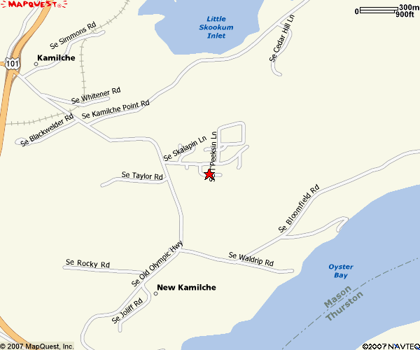

Secondary EOC Map:



