Event Recycling Bin Loaner Program

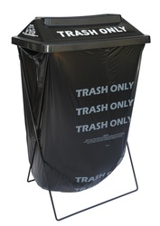
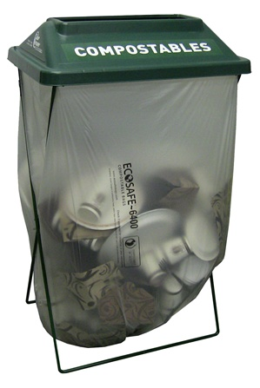
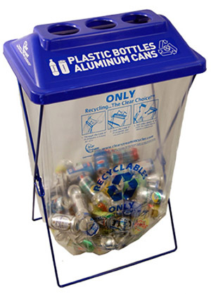
What are Event Recycling Bins?
Event recycling bins are made up of collapsable wire frames, removable lids, and free-hanging bags. They come in blue, green, and black for recyclables, compost, and trash. They are easy to move, making them ideal for events or parties. You can set up recycling and/or compost bins to compliment pre-existing trash bins or you can check out black wireframe bins to make uniformed waste station.

Who can borrow the Event Recycling Bins?
Anyone organizing an event can borrow the wireframe bins. We especially encourage their use by the Squaxin Island Tribal community, other tribes, and other events within Mason County. The bins are loaned out on a first come, first serve basis.

How many Event Recycling Bins should I ask for?
Generally, one bin or waste station should be used for every 100 guests. This can vary depending on size of event space and attributes of facilities. We can help you decide how many to borrow. At this time there are up to eighteen bins available of each color.

What can I collect in the Event Recycling Bins? What do I do with the waste I collect at the event?
Typically, plastic beverage bottles and aluminum cans are collected in the blue recycling bin. Glass should never be placed in these bins. Recycling collected from Squaxin Tribal events (such as funerals, staff parties, and meetings) can be taken to the commingle bin inside the Tribal Center, given there is enough room. Otherwise, recycling can be delivered to one of the following locations or to another location of the event organizer’s choice:
Union Drop Box
1391 McReavy Rd, Union
360-898-3037
Sunday and Monday 9am-4pm
Mason County Transfer Station
501 W. Eells Hill Road, Shelton
360-427-5271
Tuesday-Saturday 8am-4pm
Wilson Recycling
2278 E Brockdale Rd Shelton
360-432-4444
Monday-Saturday 8:30am-5pm
A small fee of $3 may be required
Garbage can be disposed through the method provided at the event facility. Limited composting services may be available for Squaxin Island Tribal events. Please ask about this option when you call to reserve your bins. Otherwise, event organizers who have a private method for compost may dispose of food waste through the method of their choice and collect any compostable products their private source will accept.

Are bags provided?
Bags are provided for Squaxin Island events and for private events hosted by Squaxin Island community members.

Are signs provided?
Laminated 11”x18” signs are provided and custom made to show the materials you plan to collect. Signs can be attached with packing tape to the front of the lids or adhered to the wall behind the bins. Signs should be returned with the Event Recycling Bins.

How do I borrow Event Recycling Bins?
Contact Sheena Kaas, Solid Waste and Recycling Program Manager at 360-432-3907 or skaas@squaxin.us. If unavailable, contact Pamela Hillstrom, DCD Program Services Manager at 360-432-3951 or phillstrom@squaxin.us.

When do I pick up and return the wireframe bins?
Bins can be picked up and returned Monday through Friday 7:30am-4pm. At time of reservation, time arrangements will be made to pick up and drop of the bins.

What happens if the bins are damaged or lost?
A $50 replacement fee will be charged to private borrowers for each bin that is returned in unusable condition or is lost.

How can I make recycling successful at my event?
- Place trash and recycling bins together. There should be a recycling bin for every trash container.
- Place the bins in strategic locations, such as in high traffic areas. If after the event has begun you notice they would work better elsewhere, move them.
- Promote recycling by providing signage or making announcements.
- Help your guests. If appropriate, have someone stand near the bins to remind guests where to place recyclables.

